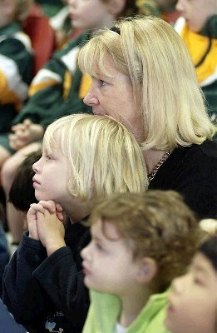
Worship encounter
Central understanding: the primary action of worship is that God comes to us with the gifts of life; our calling is one of response to God and towards each other
Key question: why is Lutheran worship central to life in a Lutheran school?
Biblical narrative: Jesus meets his friends on the road to Emmaus (Luke 24:13-34)
Theological perspective: worship
Response: issues specific to worship
Short Trails
Art Short Trail: Select two or more from the range of art works and respond according to the guiding notes.
Music Short Trail: Select one or more of the arrangements for the musical options:
- Jesu, joy of man's desiring
- How great is our God
- He reigns
- Here I am to worship
- Psalm 148
Each has a YouTube link. After listening, respond according to the guiding notes.
Reading Short Trail: Additional readings from a range of sources can be used to expand, extend and challenge their thinking about worship.
Liturgy Short Trail: Select, study and reflect on one or two of the listed liturgies and respond according to the guiding notes or
- compare a school order of service with features of worship described in their notes or The Lutheran article The practice of worship (July 2008)
- follow the Seasons of creation prompts and reflect on the God who is worshipped and on the worshippers.
Places and Spaces Short Trail: Think about and respond to worship space
- visuals
- architecture
- design
- furnishing
SMS Short Trail: Summarise, More views, Synthesise
Work with any of the three options:
- responses to prompts
- questions
- responses to statements on worship
Click here to return to Pathways: theological focus homepage

