Term 2 Week 7
(THEME: Humility)

(Please note that the theme HUMILILTY runs for two weeks)

LIFELONG QUALITIES FOR LEARNERS STATEMENT
Humility (humbleness, modesty, unassuming nature, meekness, gentleness …

Acting with humility involves recognising and valuing one’s own gifts/abilities and the gifts/abilities of others as being equally valid but of no lesser or greater importance. It is using those gifts/abilities in service to others with an attitude of selflessness. It is being thankful rather than boastful and willing to respect and learn from the experience of others.

Proverbs 22:4, Matthew 5:5, Matthew 20:20-28, Mark 9:35, Philippians 2:3-4 …

CODE OF ETHICS statement
Humility
We recognise and value the gifts and abilities of others equally to our own and therefore respect and learn from their experience
Therefore we:
+ acknowledge and support the personal strengths, professional experience and diversity of colleagues
+ demonstrate the ability and willingness to work effectively in teams
+ make every effort to use constructive methods to manage conflict and differences of opinion in a spirit of collegiality, without blame and with respect for different opinions, strategies, practices and viewpoints
+ give respectful feedback and accept feedback
+ are aware of the role of other professionals, services and agencies that can assist us support students and their families, and know when to refer on

Humility is not about denying yourself or your abilities. Humility is about seeing yourself for who you really are. It is about being honest with yourself, and being willing to work alongside other people. What are some ways that you can work alongside other people with your strengths?

Key Texts, Biblical Comment and Devotional Ideas:
God blesses those who are humble, for they will inherit the whole earth. Matthew 5:5 (NLT)
The lowly will possess the land and will live in peace and prosperity. Psalm 37:11 (NLT)

The context:
The passage from Matthew 5 is taken from Jesus’ Sermon on the Mount. There is a close parallel between what Jesus says here and Psalm 37:11. Effectively, Jesus is drawing attention to the importance, value and worth of a humble heart. In Psalm 37, it is spoken in the context of a people who are discontent with what is happening in their lives. In Matthew 5, it is spoken in the context of the blessing of contentment.

Teaching thought:
The Greek word for being humble means
a. “mild” of things,
b. “tame” of animals,
c. “gentle” or “pleasant” of persons,
d. “kindly” or “lenient” of such things as activities or punishments.
The adverb denotes quiet and friendly composure.
In Matthew, the word denotes a confident trust in God… “In Matthew 11:25ff Jesus calls himself humble… His is a lowly mission, and his heart is fixed only on God; for this very reason he can invite with full authority. In 21:5 (cf. Zech. 9:9) he makes a peaceful entry into Jerusalem in sharp contrast to Zealot hopes. In Mt. 5:5 the meek to whom the inheritance is promised are those who acknowledge the great and gracious will of God. The emphasis here is on the future; they will rule with God in the future…” (from Kittel, G., Friedrich, G., & Bromiley, G. W. (1985). Theological Dictionary of the New Testament (930). Grand Rapids, MI: W.B. Eerdmans.

Discuss:
Young children often confuse the difference between the word humility and humiliated. Discuss the differences between these two concepts.

Consider the biblical understanding of humility (in Matthew 5 and Psalm 37). In what respects does living with humility impact the internal confidence from which a person lives?

John Calvin once wrote, “We are all so blinded and upset by self-love that everyone imagines he has a just right to exalt himself, and to undervalue all others in comparison to self. If God has bestowed on us any excellent gift, we imagine it to be our own achievement, and we swell and even burst with pride.” (Golden Booklet of the True Christian Life). In what respects can having our self-esteem shaped by our understanding of who God says that we are, provide a more holistic way for living?

Consider the following quote from Martin Luther… “True humility does not know that it is humble. If it did, it would be proud from the contemplation of so fine a virtue.”

Reflect and talk about the following blog entry…
“It is good for me to think about humility today.
My feelings were hurt and anger followed.
Yes, it is good for me to think about humility today.
About thankfulness and gifts.” (Nance Marie)

Write a class definition Humility…

Additional Resources:
http://www.youtube.com/watch?v=NCHnK5ZK9iI (18 Minute TED Video on Practicing Moral Humility
http://www.youtube.com/watch?v=Z40KT8yzZak Exploring what people think about the difference between Pride and Humility
http://www.youtube.com/watch?v=gf3s-Lu5Rf4 Sam Spry on humility

Symbols
What do the following symbols suggest about Humility.

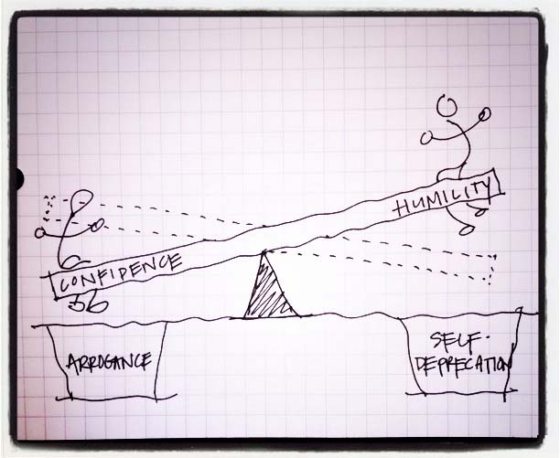

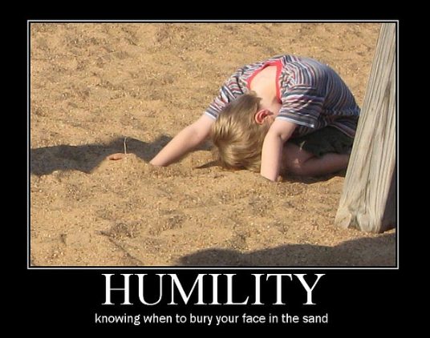

Inspirational Item
Use a teaspoon to reflect on what humility might mean.

Action/Response:
Spend some time reflecting on ways that you can reflect humility in class.

