Term 2 Week 6
(THEME: Service)

(Please note that the theme SERVICE runs for two weeks)

LIFELONG QUALITIES FOR LEARNERS STATEMENT
Service (help, assistance, benefit, good turn, aid, support, good deed, charitable act, faithfulness …

There is a saying you can serve without loving, but you cannot love without serving. Service involves selfless giving, loving others and making a difference in their lives by identifying and responding to their needs, individually and collectively, and carrying out that service without expecting recognition or reward.

Luke 12:35-37, Matthew 20:28, John 12:26, John 13:12-17 …

CODE OF ETHICS statement
Service
We give our love, time, energy, gifts in response to the needs of others and to make a difference in their lives without expecting recognition or reward
Therefore we:
+ put the needs of others ahead of our own personal agendas
+ do not seek recognition at the expensive of professional objectivity
+ consult with parents and caregivers when making decisions which have an impact on the education or wellbeing of a student
+ respond to others’ concerns in a timely and appropriate manner
+ do not exploit our position for personal or financial gain
+ ensure that personal and financial interests do not interfere with the performance of our duties

SERVICE - To have a heart for service is to give of our love, time and energy without seeking a response. Jesus demonstrated his heart for Service in his willingness to die on the cross for us. What are some ways that you can serve others at home or in the wider community?

Key Texts, Biblical Comment and Devotional Ideas:
Those who love their life in this world will lose it. Those who care nothing for their life in this world will keep it for eternity. Anyone who wants to be my disciple must follow me, because my servants must be where I am. And the Father will honor anyone who serves me. John 12:25–26 (NLT)

The context:
This passage is part of a greater whole (see John 10-12) all speaking about choice. Immediately preceding v25-26, Jesus talks about the great Christian paradox (also known as the Theology of the Cross) whereby death is the way to life. Jesus invites his disciples to consider where they stand… are they prepared to die, in order to really live? While tradition tells us that all of the disciples (except one) were most likely martyred, in our context today, Jesus is no so much speaking about a physical death as he is speaking about an ego death – a dying to self.

Teaching thought:
Dying to self is a central component of genuine service. It places the needs of others above one’s own needs and rights.

Discuss:
“Jesus talked a lot about weakness, about losing, about carrying our cross, about denying ourselves; “it is in dying that we find new life” (Matthew 10:39). The apostle Paul spoke about finding strength in weakness (2 Corinthians 12:10). Being broken is the start of real life and real strength, because it is the start of finding a strength that is not a response to fear.” In what ways does choosing to serve others enable one to not respond to people in fear?

Consider and discuss the following from theologian Frank Viola; “Unbroken people don’t know how to lay their lives down and lose. They only know how to try to win. If they’re criticized, they retaliate. If they’re attacked, they return fire. If misunderstood, they defend in anger. They are capable of doing all sorts of damage to others in order to save (themselves) and keep their reputations. On the contrary, people who have been broken by the hand of God know how to turn the other cheek. They know how to go the second mile. They know how to give their coats when asked for their shirts. They know how to speak well of those who misrepresent them. They know how to return good for evil.”

Reconsider the class definition of Service (from last week). Is this still a good definition? What might you change and why?

In what ways can you serve others at school, in the playground, in the wider community?

Additional Resources:
http://www.youtube.com/watch?v=VrsgnrocNnU Drama about dying to self (funny)
http://www.youtube.com/watch?v=q2oOyKv59gQ Inspirational story about how someone made a difference

Symbols
What do the following symbols suggest about Service.

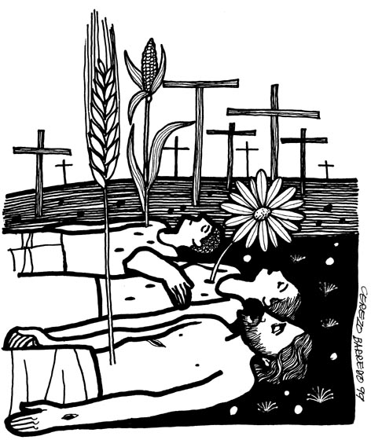

Inspirational Item
Use a ribbon or medal to explore meanings of Service.

Action/Response:
As a class, choose a service project.

