Term 2 Week 4
(THEME: Justice)

(Please note that the theme JUSTICE runs for two weeks)

LIFELONG QUALITIES FOR LEARNERS STATEMENT
Justice (integrity, honesty, truthfulness, honour, veracity, uprightness, fairness …

Through genuine concern, and the developing of a conscience for the rights and wellbeing of everyone in the human family, justice focuses as much on understanding and responding to the reasons for suffering and injustices as it does on responding to unjust conditions. It requires integrity between beliefs, words, and actions. It may necessitate taking a stand and acting with courage.

Isaiah 26:7-8, Romans 12, Matthew 5:7, Ephesians 2:1-5, Jeremiah 23:5-6, Job 8:3-7…

CODE OF ETHICS statement
Justice
Through genuine concern and through developing a conscience for the rights and well being of others, we act with fairness and consistency and respond to injustice with courage and integrity
Therefore we:
+ are fair, consistent and just in our dealings with all students, parents and caregivers, colleagues and members of the wider school community
+maintain sensitive information with appropriate confidentiality and therefore refrain from discussing school issues or others’ personal or professional problems in situations where the information may not be treated confidentially
+ are aware of and fulfil the ethical, moral and legal responsibilities to our position
+ are truthful when making statements about our qualifications and competencies

JUSTICE - Courage and Justice often go hand in hand. We need to have courage to seek justice. But justice is slightly deeper. It is about developing a conscience for the rights and well being of others. Jesus demonstrated his heart for Justice in the way he stood up for the poor, the widows and children. How can we demonstrate justice beyond our school?

Key Texts, Biblical Comment and Devotional Ideas:
God blesses those who are merciful,
for they will be shown mercy. Matthew 5:7 (NLT)

The context:
This text is quoted from Jesus’ Sermon on the Mount. In that sermon, Jesus lays down some profound truths about what it means to be part of the kingdom of God – engaging in the lives of people; the emphasis here is on character!

Teaching thought:
Why is the characteristic of justice, central to an authentic expression of the Christian faith?

Discuss:
Actor, William Dafoe once said… “One of the pleasures of being an actor is quite simply taking a walk in someone else's shoes. And when I look at the roles I've played, I'm kind of amazed at all the wonderful adventures I've had and the different things I've learned.” How does walking in someone else’s shoes better equip you to respond to them with justice.
In what situations are you able to be impartial and fair? In what situations do feel pressured to ‘bend the truth’.

Discuss the quote; “Everyone wants justice – for someone else”

Martin Luther wrote the following about this passage… “This is also an outstanding fruit of faith, and it follows well upon what went before. Anyone who is supposed to help other people and to contribute to the common weal and success should also be kind and merciful. He should not immediately raise a rumpus and start a riot if something is missing or if things do not go as they should, as long as there is still some hope for improvement. One of the virtues of counterfeit sanctity is that it cannot have pity or mercy for the frail and weak, but insists on the strictest enforcement and the purest selection; as soon as there is even a minor flaw, all mercy is gone, and there is nothing but fuming and fury St. Gregory also teaches us how to recognize this when he says: “True justice shows mercy, but false justice shows indignation.”” Luther's works, vol. 21: The Sermon on the Mount and the Magnificat (J. J. Pelikan, H. C. Oswald & H. T. Lehmann, Ed.) (Mt 5:7). Saint Louis: Concordia Publishing House. Luther is often thought of a conveyer of grace, but here, Luther strongly emphasises the natural response of faith. Why do you think, does Luther speak so passionately about the role of Christians in speaking out for justice? What do you think is the relationship between justice and mercy?

What does ‘the cross’ have to say about Justice?

Additional Resources:
http://www.youtube.com/watch?v=5sRLCitIfw8 Social Justice and Lutheran Church
http://www.youtube.com/watch?v=RNvIvwik2ug “The essence of Christianity is to be like a little Christ to your neighbour”
http://www.youtube.com/watch?v=6FUlDoUFPKA Voices of children discovering justice

Symbols

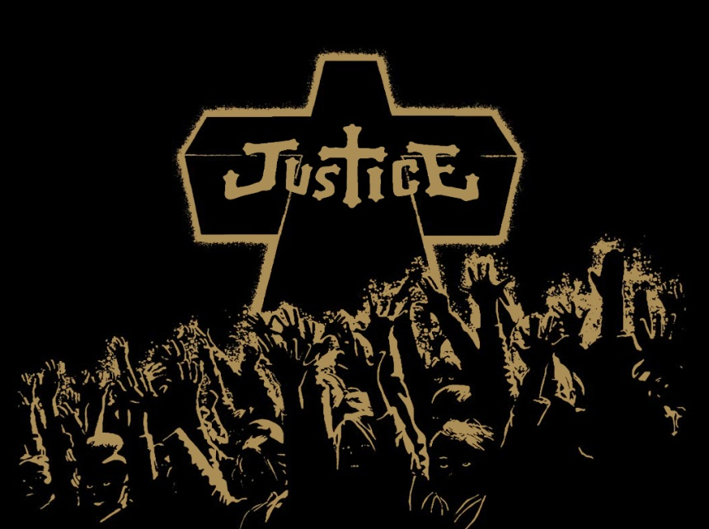

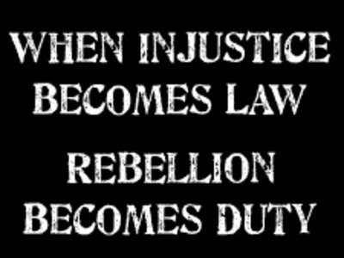

Inspirational Item
Use a cross to talk about how it relates to Justice.

Action/Response:
How might you respond?

