Term 2 Week 3
(THEME: Justice)

(Please note that the theme JUSTICE runs for two weeks)

LIFELONG QUALITIES FOR LEARNERS STATEMENT
Justice (integrity, honesty, truthfulness, honour, veracity, uprightness, fairness …

Through genuine concern, and the developing of a conscience for the rights and wellbeing of everyone in the human family, justice focuses as much on understanding and responding to the reasons for suffering and injustices as it does on responding to unjust conditions. It requires integrity between beliefs, words, and actions. It may necessitate taking a stand and acting with courage.

Isaiah 26:7-8, Romans 12, Matthew 5:7, Ephesians 2:1-5, Jeremiah 23:5-6, Job 8:3-7…

CODE OF ETHICS statement
Justice
Through genuine concern and through developing a conscience for the rights and well being of others, we act with fairness and consistency and respond to injustice with courage and integrity
Therefore we:
+ are fair, consistent and just in our dealings with all students, parents and caregivers, colleagues and members of the wider school community
+maintain sensitive information with appropriate confidentiality and therefore refrain from discussing school issues or others’ personal or professional problems in situations where the information may not be treated confidentially
+ are aware of and fulfil the ethical, moral and legal responsibilities to our position
+ are truthful when making statements about our qualifications and competencies

JUSTICE – Courage and Justice often go hand in hand. We need to have courage to seek justice. But justice is slightly deeper. It is about developing a conscience for the rights and well being of others. Jesus demonstrated his heart for Justice in the way he stood up for the poor, the widows and children. How can we demonstrate justice in our classrooms?

Key Texts, Biblical Comment and Devotional Ideas:
Jeremiah 23:5–6 (NLT)
5 “For the time is coming,”
says the LORD,
“when I will raise up a righteous descendant
from King David’s line.
He will be a King who rules with wisdom.
He will do what is just and right throughout the land.
6 And this will be his name:
‘The LORD Is Our Righteousness.’
In that day Judah will be saved,
and Israel will live in safety.

The context:
Jeremiah wrote this to warn those in leadership and power that a time would come when God will come and rule his people with great integrity, honesty and power. The religious leaders at the time were corrupt; more interested in ‘what’s in it for me’ than in standing up for what is good and true.

Teaching thought:
What is justice? The Merriam Webster Dictionary defines justice as
a: the maintenance or administration of what is just especially by the impartial adjustment of conflicting claims or the assignment of merited rewards or punishments
a: the quality of being just, impartial, or fair
b (1): the principle or ideal of just dealing or right action (2): conformity to this principle or ideal : righteousness
Justice is about doing what is right, being impartial and consistent.

Discuss:
Explore the definition of justice. Write your own definition.
Should justice always bring about punishment? In what respects are justice and punishment separate concepts?
Consider the relationship between justice and forgiveness?

Additional Resources:
http://vimeo.com/49362753 Trailer for the film Beyond Right and Wrong, and raises the question about the relationship between justice and forgiveness
http://jeffgoins.myadventures.org/?filename=three-stories-of-justice-and-and-compassion Three stories of justice and compassion…
http://www.youtube.com/watch?v=f0W8lR_DXfA Video clip about justice for women fleeing violence
http://www.youtube.com/watch?v=z754lhcX6qw What does social justice mean to you?

Symbols
Consider the following images… what words come to mind?
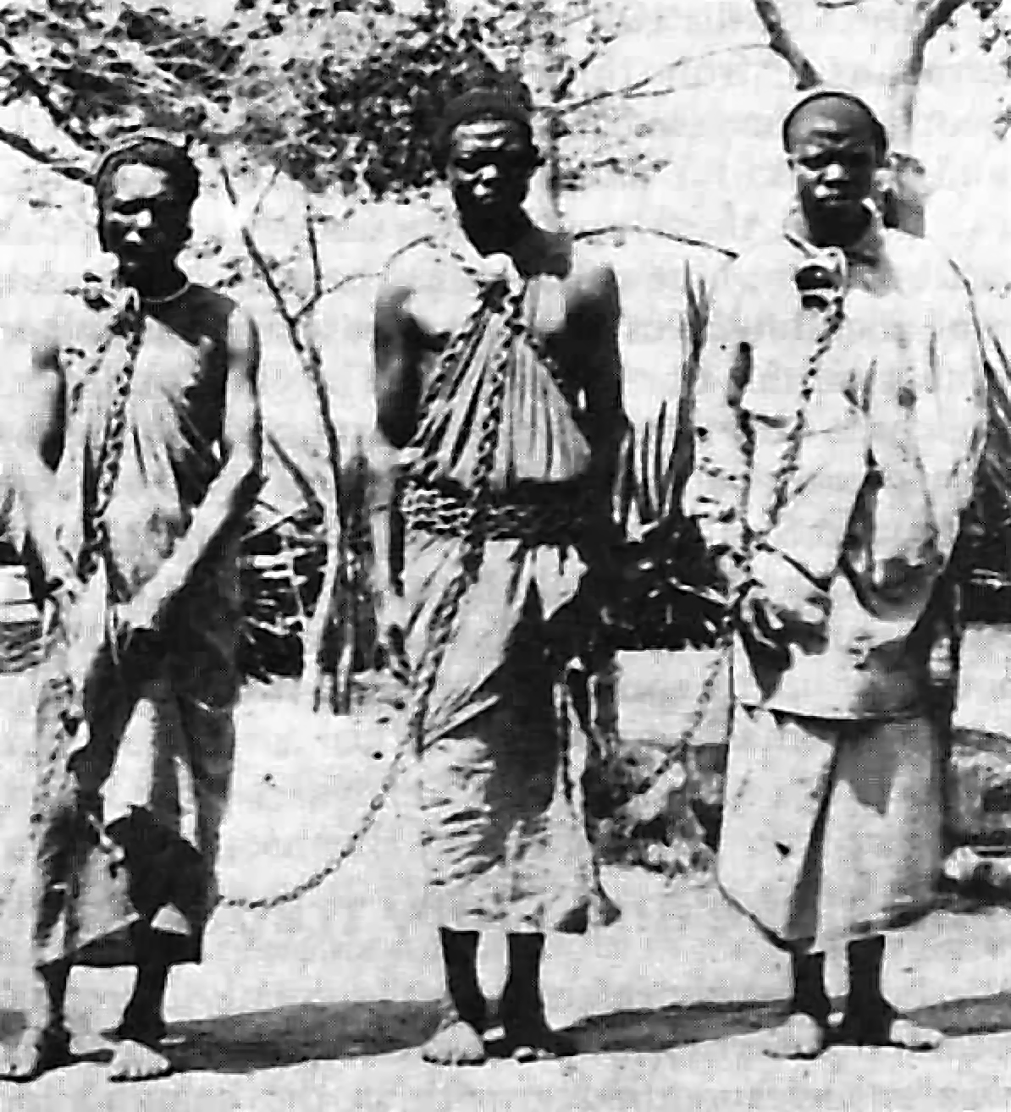

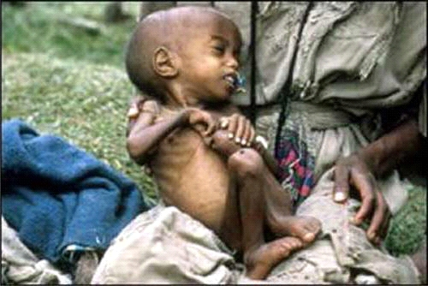

Inspirational Item
Consider a whip. What does that say about justice?

Action/Response:
As a class, consider how you might engage in the value of justice.

