Term 2 Week 2
(THEME: Courage)

(Please note that the theme COURAGE runs for two weeks)

LIFELONG QUALITIES FOR LEARNERS STATEMENT
Courage (valour, bravery, nerve, pluck, daring, fearlessness, fortitude, boldness, perseverance, intrepid …

Courage is the strength of heart that enables people to stand up for their convictions to do the right thing, even when it is hard or fearful. It involves being firm of spirit despite the ups and downs of life and it means ‘having a go’ even when success is uncertain.

Psalm 112:8, Luke 21:19, Acts 20:24, Philippians 1:27-30, 2 Timothy 1:7 …

CODE OF ETHICS statement
Courage
We have the strength of heart and firmness of spirit to stand up for what is right and ‘have a go’ despite difficulties, uncertainty and setbacks
Therefore we:
+ use constructive action and appropriate forums to debate issues and bring about change
+ challenge negative interpersonal behaviours and use appropriate processes to deal with them
+ protect students and colleagues from intimidation, humiliation and harm
+ seek advice, support and assistance when we are facing personal challenges

Key Texts, Biblical Comment and Devotional Ideas:
Above all, you must live as citizens of heaven, conducting yourselves in a manner worthy of the Good News about Christ. Then, whether I come and see you again or only hear about you, I will know that you are standing together with one spirit and one purpose, fighting together for the faith, which is the Good News. Don’t be intimidated in any way by your enemies. This will be a sign to them that they are going to be destroyed, but that you are going to be saved, even by God himself. For you have been given not only the privilege of trusting in Christ but also the privilege of suffering for him. We are in this struggle together. You have seen my struggle in the past, and you know that I am still in the midst of it. (Philippians 1:27-30, NLT)

The context:
The apostle Paul speaks about living as citizens of heaven (the Greek word refers to ‘conduct in one’s life’ or ‘one’s character’) as part of a larger discourse about Christian character (Philippians 1:20f). His emphasis is that there needs to be integrity within the character and personhood of followers of Jesus. To strive towards building this character takes courage!

Teaching thought:
In one of his books, Bill Hybels talks about the importance of being “who you are when no one is looking”. Being courageous is about having consistency of character in all situations.

Discuss:
Reflect on your definition of courage. How courageous have you been this week? How easy has it been to be courageous?
Consider one of the video clips about running. What do you notice about the person who falls down? What does that tell you about courage?
For Paul, to be courageous was to stand together ‘in one spirit and purpose’. What would need to happen in order for our community to stand together ‘in one spirit and purpose’? What changes would need to happen in your life?

Additional Resources:
http://www.youtube.com/watch?v=R7x9fRsdcNo (high school running race)
http://www.youtube.com/watch?v=kZlXWp6vFdE (Barcelona Olympics)
http://www.youtube.com/watch?v=NsOBaV_93yQ (Girl wins race despite falling)

Use a story from
http://www.wisdomcommons.org/virtues/29-courage

Symbols
Use one of the following pictures or symbols to explore what that picture might suggest about the topic.

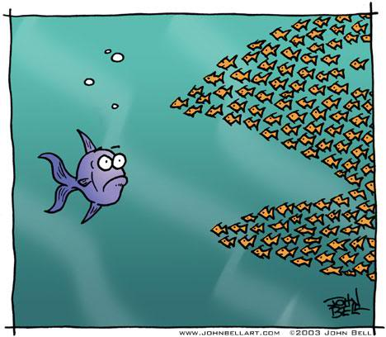
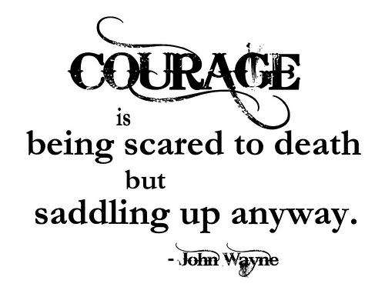

Inspirational Item
Each inspirational item is an abstract item with no ‘obvious’ link to the Bible or the Christian faith – this is where the challenge begins! We challenged students and teachers to find that link, to make sense of that item and see where it has meaning in our Christian lives.





Action/Response:
How might you respond?

