Term 2 Week 10
(THEME: Compassion)

(Please note that the theme COMPASSION runs for two weeks)

LIFELONG QUALITIES FOR LEARNERS STATEMENT

Compassion (mercy, sympathy, empathy, concern, kindness, consideration, gentleness, care …
Having compassion is being loving and attending to people’s innermost needs. It is exercising the ability to reach out, to walk in another’s shoes, to be open and responsive to the needs and concerns of others and being active in caring for others.

Philippians 2:1, Hosea 11:4, Matthew 5:44, John 15:17, Romans 12:9-13, Colossians 3:12-15 …

CODE OF ETHICS statement
Compassion
We are open and responsive to the needs and concerns of others, and exercise the ability to reach out and actively care for them
Therefore we:
+ take notice of others’ reactions to our actions, tone of voice and manner
+ raise any concerns, issues, problems with the appropriate level of school management as soon as possible
+ ensure all allegations and suspicions of abuse to young people are recorded and acted upon
+ ensure that our personal behaviour does not contribute to inappropriate conduct by others
+ ensure that any physical contact with a child is in response to the situation, the needs and wishes of that child, non-secretive and appropriate for the child’s age, health and developmental stage
+ recognise that social relations between staff and students can be problematic

COMPASSION– To have compassion is to see a need somewhere else and respond to it. Jesus demonstrated his compassion for us in his coming to live among us. How can we show compassion to others in the wider community?
Key Texts, Biblical Comment and Devotional Ideas:
““When Israel was a child, I loved him, and I called my son out of Egypt. But the more I called to him, the farther he moved from me, offering sacrifices to the images of Baal and burning incense to idols. I myself taught Israel how to walk, leading him along by the hand. But he doesn’t know or even care that it was I who took care of him. I led Israel along with my ropes of kindness and love. I lifted the yoke from his neck, and I myself stooped to feed him.” (Hosea 11:1–4, NLT)
The context:
The story of Hosea is the story of God’s love for his people. God instructed Hosea, the prophet, to marry a prostitute, someone who would be unfaithful to him. God used this as a metaphor for how the people of Israel responded to his love for them.

Teaching thought:
Compare two different thoughts about love; conditional love, which expects a return and unconditional love, which loves no matter what. What sort of love is genuine? What does this have to say about compassion?

Discuss:
As you read through Hosea 11, what do you notice about how Israel responded to God’s love? How did God respond? What change do you think that might have made? Would God have continued to respond that way?

Reflect on the following story
Tanzan and Ekido, two monks, were once traveling together down a muddy road. A heavy rain was still falling. Coming around a bend, they met a lovely girl, unable to cross the intersection. “Come on, girl.” said Tanzan. Lifting her in his arms, he carried her over the mud.
Ekido did not speak again until that night when they reached a lodging place. Then he no longer could restrain himself. “We monks don’t go near females,” he told Tanzan, “especially not young and lovely ones. It is dangerous. Why did you do that?”
“I left the girl there,” said Tanzan. “Are you still carrying her?”

Discuss the following quote and talk about how it understands the concept of compassion…
“Deserves it! I daresay he does. Many that live deserve death. And some that die deserve life. Can you give it to them? Then do not be too eager to deal out death in judgement. For even the very wise cannot see all ends.” ― J.R.R. Tolkien, The Fellowship of the Ring

Discuss the following quote and talk about how it understands the concept of compassion…
“It is easy enough to be friendly to one's friends. But to befriend the one who regards himself as your enemy is the quintessence of true religion. The other is mere business.” ― Mahatma Gandhi

Discuss the following quote and talk about how it understands the concept of compassion…
“True compassion is more than flinging a coin to a beggar; it comes to see that an edifice which produces beggars needs restructuring. ” ― Martin Luther King Jr.

Review your class definition of compassion.

Additional Resources:
http://www.youtube.com/watch?v=IrOqnZdvI6M Fellowship of the Ring… Discuss Gandalf: "So do all who live to see such times but that is not for them to decide. All we have to decide is what to do with the time that is given to us."
http://www.youtube.com/watch?v=Agnqm6wjNYs&list=UUCmmXWNSTmxsSGvWiJa7PeA&index=3 Fun song about Compassion (To the tune of Taylor Swift – Never Getting Back Together)
http://www.youtube.com/watch?v=8tL93AhVi0s Video clip based on the apostle John about compassion
http://www.youtube.com/watch?v=cxuJ2N1rjXA Video Clip from Compassion Project
http://www.youtube.com/watch?v=-tsI4Kec9os 40 Hour Famine Promo
http://www.youtube.com/watch?v=KFZz6ICzpjI&list=PL62460088C701D8D4 Teenage Affluenza
http://www.youtube.com/watch?v=gAeb3Fl85yI Satire video clip about affluenza

Symbols
What do the following images suggest about Compassion.
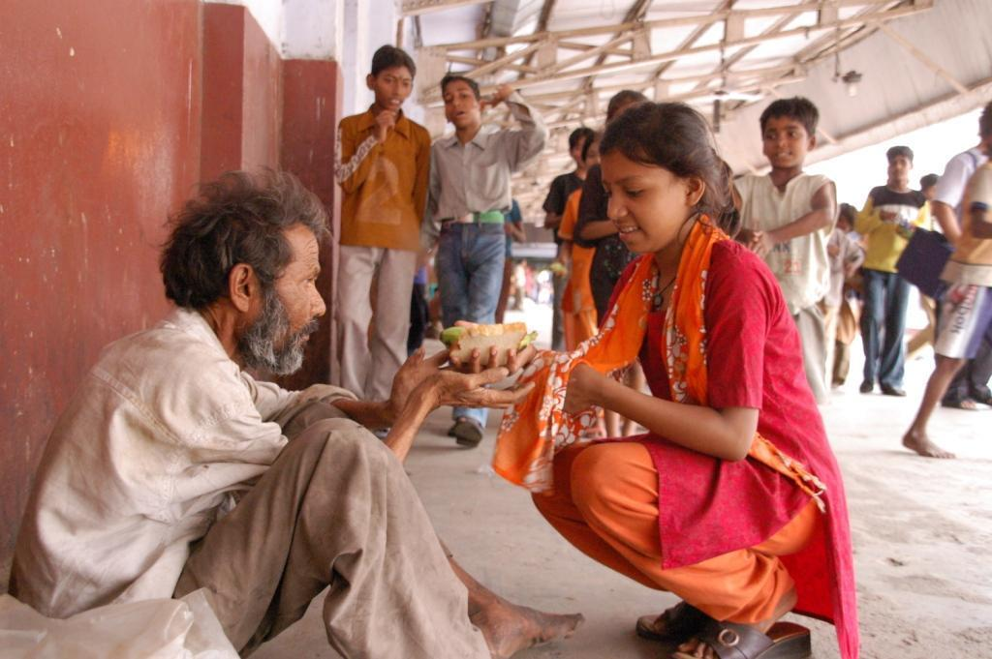







Inspirational Item
Use a clock to explore compassion.

Action/Response:
Consider taking part in 40 Hour Famine this year.

