Term 2 Week 1
(THEME: Courage)

(Please note that the theme COURAGE runs for two weeks)

LIFELONG QUALITIES FOR LEARNERS STATEMENT
Courage (valour, bravery, nerve, pluck, daring, fearlessness, fortitude, boldness, perseverance, intrepid …

Courage is the strength of heart that enables people to stand up for their convictions to do the right thing, even when it is hard or fearful. It involves being firm of spirit despite the ups and downs of life and it means ‘having a go’ even when success is uncertain.

Psalm 112:8, Luke 21:19, Acts 20:24, Philippians 1:27-30, 2 Timothy 1:7 …

CODE OF ETHICS statement
Courage
We have the strength of heart and firmness of spirit to stand up for what is right and ‘have a go’ despite difficulties, uncertainty and setbacks
Therefore we:
+ use constructive action and appropriate forums to debate issues and bring about change
+ challenge negative interpersonal behaviours and use appropriate processes to deal with them
+ protect students and colleagues from intimidation, humiliation and harm
+ seek advice, support and assistance when we are facing personal challenges

Key Texts, Biblical Comment and Devotional Ideas:
By standing firm, you will win your souls. Luke 21:19 (NLT)
Stand firm, and you will win life. Luke 21:19 (NIV)

The context:
Jesus speaks these words to his disciples. In them, he is foretelling the future. He is drawing attention to two sieges of Jerusalem that would take place in the next half century. It is thought that Luke 21:24 is in reference to the siege by Titus in 70AD.

The underlying concept in verse 19 is that of being courageous. The Greek word used for “Standing firm” also implies having endurance, waiting patiently; see Romans 5:3,4 and 2 Peter 1:6.

Teaching thought:
What does it mean to be courageous? To have courage is to hold true to who we really are! It is to be consistent with that reality, even when no one is looking. Or, as the code of ethics statement reads… it is to have the strength of heart and firmness of spirit to stand up for what is right and ‘have a go’ despite difficulties, uncertainty and setbacks
To be courageous in faith is to have a certainty that God is in control, even when everything else seems to be falling down. This can create an inner peace of the sort of which the apostle Paul describes as ‘a peace which passes all human understanding”.

Discuss:
How do you define courage?
What is the most courageous thing you have ever done? What happened? What did you discover about yourself?
In what ways does being a follower of Jesus increase your capacity to be courageous?
Reflect on the story of Good Friday. In what ways was Jesus’ actions courageous?
Consider how Peter had responded before the cock crowed (ie. three times he denied knowing Jesus). What would you have done? Why? What do you think turned Peter around from being fearful to being confident? (Read Luke 22:54-65)

Additional Resources:
http://www.youtube.com/watch?v=GvgLq431wFY (A clip from the course Stepping Up about being manhood)
http://www.youtube.com/watch?v=mLiRuu_-SIY (story of Dietrich Bonhoeffer)
http://www.youtube.com/watch?v=LNIuxpaOwIQ (Children’s video clip on Courage)

Use a story from
http://www.wisdomcommons.org/virtues/29-courage

Symbols
Use one of the following pictures or symbols to explore what that picture might suggest about the topic.
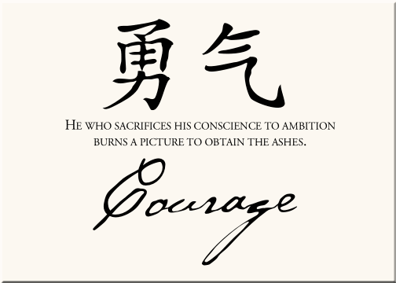

http://www.mysticmadness.com/strength-and-courage-symbols-from-12-different-cultures.html

Inspirational Item
Each inspirational item is an abstract item with no ‘obvious’ link to the Bible or the Christian faith – this is where the challenge begins! We challenged students and teachers to find that link, to make sense of that item and see where it has meaning in our Christian lives.



Action/Response:
How might you respond?

