Term 1 Week 9 (Lutheran Schools Week)
(THEME: Appreciation) Please note that Easter is at the end of this week

(Please note that the theme APPRECIATION runs for two weeks)

LIFELONG QUALITIES FOR LEARNERS STATEMENT
Appreciation (admiration, approval, enjoyment of, gratitude, thankfulness, value, recognition, respect, wonder and awe, comprehension …

Appreciation is recognising and valuing highly the gifts and blessings given to us and surrounding us. It is an attitude of gratitude for learning, loving and being. It is a positive attitude that responds in wonder and awe to, and with respect for, the created world – its fragility and its potential.

Psalm 148, Habakkuk 2:20, Philippians 4:4-9, 1 Thessalonians 5:18, 1 Pet 2:17,…

CODE OF ETHICS statement
Appreciation
We recognise and value highly the gifts and blessing given to us and surrounding us
Therefore we:
+ recognise and value the gifts and talents of others
+ celebrate the positive aspects of our work environment
+ provide and care for each other
+ value and care for school property and other physical assets

Key Texts, Biblical Comment and Devotional Ideas:
Always be full of joy in the Lord. I say it again—rejoice! Let everyone see that you are considerate in all you do. Remember, the Lord is coming soon. Don’t worry about anything; instead, pray about everything. Tell God what you need, and thank him for all he has done. Then you will experience God’s peace, which exceeds anything we can understand. His peace will guard your hearts and minds as you live in Christ Jesus. (Philippians 4:4-7, NLT)

The context:
The apostle Paul was not averse to hardship. He experienced many struggles – prison, beatings, shipwrecks. Yet in the midst of all of these, he encouraged Jesus’ followers to be full of joy in every circumstance.
The word “considerate” (in verse 5), comes from the Greek root meaning “to yield”, or “to have reasonableness in dealings”, or “to not urge one’s own rights to the utmost”. In this respect, Paul is stating that part of a Christian response to situations, is to see it as part of something greater – we are to embrace an ethic of community, rather than an ethic of autonomy.
In essence, to look for God even in the tough times, is to recognise his constant presence, thus enabling people to experience God’s peace.

Teaching thought:
Why is it that some people seem to have a natural predisposition to seeing good, and other’s see bad. There is a story about a psychologist who holds a half glass up. Thinking she was going to do the ‘half glass full/half glass empty’ thing, there was a groan across the room. But instead she asked… I don’t care whether you see this as half glass full or empty. It is half a glass of water. The question you need to ask for yourselves, is “how long do you want to hold it for”? A half glass held for a short time is ‘doable’. A half glass held for 2 hours is painful.
The point: Stuff happens! How we look at the stuff that happens, and how long we hold it is the key question.

Discuss:
Tell the above story. What do you think is the point?
What stops you from appreciating those things that you have? What does that tell you about who you are?
What do you think is the value of ‘telling God what you need’?
How beneficial is it to consider that God is always in control?
What are some things that you have over which you can grow in thankfulness and appreciation?
Consider again the definition of Appreciation that you may have written up as a class at the beginning of the year. Are there things that you might want to change about it?

Additional Resources:
http://www.youtube.com/watch?v=lfXOlNPnutA Upbeat music by Mary Mary
http://www.youtube.com/watch?v=Bpb9EbmvM5M Muppet Christmas Carol – Thankful Heart
http://www.youtube.com/watch?v=u_h0fmVfNbM Someone questioning what we should really be thankful for
http://www.youtube.com/watch?v=8cB_qjRLuXY Things not thankful for

Symbols
Use one of the following pictures or symbols to explore what that picture might suggest about the topic.

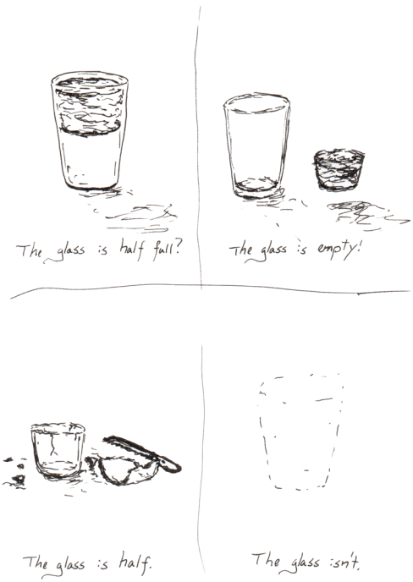

Inspirational Item
Each inspirational item is an abstract item with no ‘obvious’ link to the Bible or the Christian faith – this is where the challenge begins! We challenged students and teachers to find that link, to make sense of that item and see where it has meaning in our Christian lives.

Action/Response:
How might you respond to the cross?
Spend some time reflecting on the Easter story.

