**Term 1 Week 8**

**THEME: Appreciation**

**Also NOTE that Sunday, end of Week 8 is Palm Sunday**

(Please note that the theme APPRECIATION runs for two weeks)

**LIFELONG QUALITIES FOR LEARNERS STATEMENT**

Appreciation (admiration, approval, enjoyment of, gratitude, thankfulness, value, recognition, respect, wonder and awe, comprehension …

Appreciation is recognising and valuing highly the gifts and blessings given to us and surrounding us. It is an attitude of gratitude for learning, loving and being. It is a positive attitude that responds in wonder and awe to, and with respect for, the created world – its fragility and its potential.

Psalm 148, Habakkuk 2:20, Philippians 4:4-9, 1 Thessalonians 5:18, 1 Pet 2:17,…

**CODE OF ETHICS statement**

**Appreciation**

*We recognise and value highly the gifts and blessing given to us and surrounding us*

*Therefore we:*

*+ recognise and value the gifts and talents of others*

*+ celebrate the positive aspects of our work environment*

*+ provide and care for each other*

*+ value and care for school property and other physical assets*

**Key Texts, Biblical Comment and Devotional Ideas:**

Praise the LORD!

Praise the LORD from the heavens!

Praise him from the skies!

Praise him, all his angels!

Praise him, all the armies of heaven!

Praise him, sun and moon!

Praise him, all you twinkling stars!

Praise him, skies above!

Praise him, vapors high above the clouds!

Let every created thing give praise to the LORD,

for he issued his command, and they came into being.

He set them in place forever and ever.

His decree will never be revoked.

(Ps 148:1–6, NLT)

***The context:***

There is a relationship between Psalm 148 and the celebration of the rebuilding of Jerusalem (see Nehemiah 6:16, 12:27). It is a time of celebration when, after years of heartache, a new hope was formed and Jerusalem, once again, became central to the worship life of the Israelites.

***Teaching thought:***

The history of the Israelites, just as history itself, tells us that life is filled with ebbs and flows. When times are good, people often forget the centrality of their Creator. And so, they take Him for granted. And, as with many things, when we take things for granted (family, friends, even our jobs etc) we quickly become self involved. The Psalm is a call, so to speak, to slow down and “stop and smell the roses” – and say thank you.

***Discuss****:*

Pause in your classroom for a moment. Listen quietly. What do you hear? What would life be like without those noises? What would you be missing?

What are some things that you most appreciate within the college?

“A man was driving down the road one day, when his little girl urgently called out, ‘Stop!’. The man screeched to a stop and turning around said to his daughter, ‘What is the problem darling?’ The little girl pointed at the developing colourful sunset and said, ‘I just wanted you to see the amazing picture that God is painting.’ How do you think the dad would have responded?

***Additional Resources:***

<http://www.youtube.com/watch?v=AE_BX1XUSC4> God’s Creation

<http://www.youtube.com/watch?v=Frz43ncf-R8> God’s Creation 2

<http://www.youtube.com/watch?v=MgJ_WP18hnY> In the beginning (montage of stars and universes)

<http://www.youtube.com/watch?v=OPDimGnpv4g> A reflective video clip filled with images

<http://www.youtube.com/watch?v=gaGkgCmP2O0> Student video asking people what they are thankful for

***Symbols***

Use one of the following pictures or symbols to explore what that picture might suggest about the topic.

 

***Inspirational Item***

Each inspirational item is an abstract item with no ‘obvious’ link to the Bible or the Christian faith – this is where the challenge begins! We challenged students and teachers to find that link, to make sense of that item and see where it has meaning in our Christian lives.

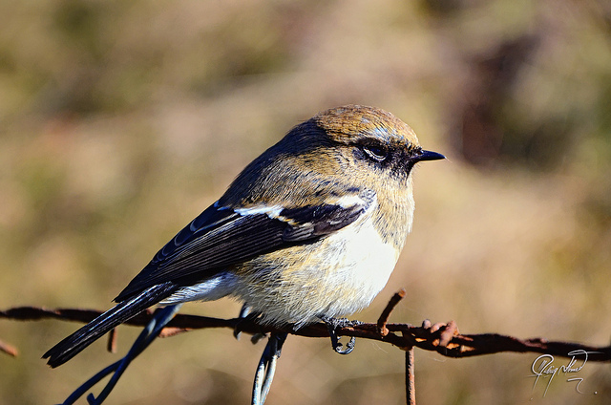

***Action/Response:***

How might you respond?

What are some specific activities you might choose to do this week to demonstrate that you value the school and its property?

Who is someone you seldom say thank you to? Identify something about them that is unique and special and write a note or do something to demonstrate your appreciation.