LEA Values; a framework for living

Values provide a framework for decision making. The Lutheran Education Australia framework, Lifelong qualities for learners “defines the ethos of Lutheran Schools: ‘As central to their mission and ministry, Lutheran schools seek to nurture individuals who are aware of their humanity, open to the influence of the holy spirit and growing in and living according to a cohesive worldview while living in community and reflecting the characteristics of God through core values, especially love, justice, compassion, forgiveness, service, humility, courage, hope, quality and appreciation” (LEA Statement of Values).

This resource provides thought starters, theological underpinnings and suggestions as to how this framework can be utilised in classroom devotions and college worship and staff bible studies.

A word of note: this resource has been compiled to run across campuses – so adaptation will need to be made to make it age appropriate. Use those resources that are helpful. If you find other resources, email them to me, so that they can be made available to others for future years.

Term 1 Week 6
(Please note that the theme FORGIVENESS runs for two weeks)

LIFELONG QUALITIES FOR LEARNERS STATEMENT
Forgiveness (benevolence, grace, mercy, amnesty, excuse, pardon, understanding, kindness, absolve, acquit, reprieve …

Forgiveness is breaking the cycle of un-grace, pardoning the wrongs others have done to us and seeking pardon for the wrongs we have done to others. Forgiveness often comes with pain and can involve stepping over our hurt. Forgiveness releases both ourselves and others, enabling new starts and new beginnings, another chance.

Matthew 18:21-22, Luke 17:3-4, Romans 4, Colossians 3:13, Matthew 5:7, Ephesians 4:32 …

CODE OF ETHICS statement
Forgiveness
We pardon the wrongs others have done to us, seek pardon for the wrongs we have done to others and in doing so, focus on making a new start
Therefore we:
+ deal proactively, openly and decisively with dysfunctional relationships and see them as opportunities for God to transform and heal
+ accept our obligations to put damaged relationship right
+ understand that genuine forgiveness can be a difficult process, but that it is a biblical imperative, made possible in the lives of people through the grace of God
+ accept that at times our actions lead to consequences (including disciplinary action) and that these are not incompatible with forgiveness

Key Texts, Biblical Comment and Devotional Ideas:
Then Peter came to him and asked, “Lord, how often should I forgive someone who sins against me? Seven times?” “No, not seven times,” Jesus replied, “but seventy times seven!” (Matthew 18:21-22, NLT)

The context:
Notice the context of Matthew 18. It begins with Jesus talking about having to become like children, in order to be great in the kingdom of God, proceeds into the Parable of the Lost Sheep – which speaks about the importance of people who are separated from God, then enters into a discussion about how to raise issues with believers who ‘sin again you’, then concludes with an expression of how much people are to forgive each other.

Teaching thought:
Considering the context of this passage, it seems apparent that people who do the wrong thing, or people who hurt others, can never be simply discarded because of what they have done wrong. Instead, God’s heart is to seek them out (parable of the Lost Sheep) and to restore them back into relationship with others.
The number 7 in biblical times was considered a special, or divine number. According to some teachers of Jesus day, to forgive 7 times was deemed to be forgiven enough – at which point those people were to be cast out, or excommunicated from the community. Here, Jesus is implying that while a person is sincerely seeking forgiveness we are to forgive them.

Discuss:
Why is forgiveness important?
Who is forgiveness for? (the forgiver, or the forgivee)?
Our Life Long Learner comment suggests that forgiveness breaks the cycle of un-grace. What do you understand by that? Are there any stories that you can share which demonstrate that?
Using a piece of timber and a hammer, hit nails into the timber – indicating how people hurt each other. Then pull out the nails as a sign of being forgiveness. What do you notice about the piece of timber? What might the left over holes imply about forgiveness?
Discuss the comment, “You know that you have forgiven someone when to remember the moment no longer hurts”. Do you agree or disagree?

Additional Resources:
http://www.youtube.com/watch?v=3D4VMZb8wLY Video with inspirational phrases about the journey of forgiveness
http://www.youtube.com/watch?v=o2BITY-3Mp4 News story about a woman who forgives her sons murderer – indeed, who now lives next door to them
http://www.youtube.com/watch?v=iv50xrsFNdU A Video about forgiveness with Mary Karen Read's last words in her journal entry before her death at the Virginia tech shooting

Symbols
Use one of the following pictures or symbols to explore what that picture might suggest about the topic.
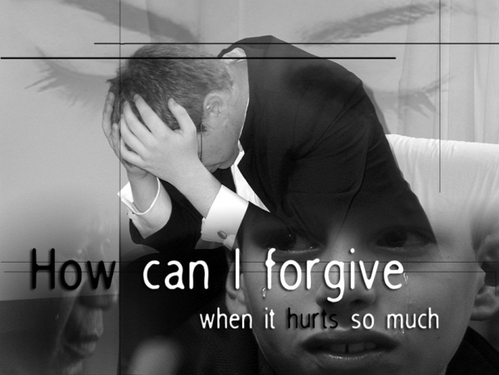

Inspirational Item
Each inspirational item is an abstract item with no ‘obvious’ link to the Bible or the Christian faith – this is where the challenge begins! We challenged students and teachers to find that link, to make sense of that item and see where it has meaning in our Christian lives.

Action/Response:
How might you respond?

