LEA Values; a framework for living

Values provide a framework for decision making. The Lutheran Education Australia framework, Lifelong qualities for learners “defines the ethos of Lutheran Schools: ‘As central to their mission and ministry, Lutheran schools seek to nurture individuals who are aware of their humanity, open to the influence of the holy spirit and growing in and living according to a cohesive worldview while living in community and reflecting the characteristics of God through core values, especially love, justice, compassion, forgiveness, service, humility, courage, hope, quality and appreciation” (LEA Statement of Values).

This resource provides thought starters, theological underpinnings and suggestions as to how this framework can be utilised in classroom devotions and college worship and staff bible studies.

A word of note: this resource has been compiled to run across campuses – so adaptation will need to be made to make it age appropriate. Use those resources that are helpful. If you find other resources, email them to me, so that they can be made available to others for future years.

Term 1 Week 5
(Please note that the theme LOVE runs for two weeks)

LIFELONG QUALITIES FOR LEARNERS STATEMENT
Love (adore, worship, care for, devotion to, fidelity, kindness, peace, trust, resilience, happiness, have esteem for, honour …

For Christians, the expression of love is always a response to God’s love. It is a way of being that leads to inner peace. Love flows from the heart and manifests itself in caring, kind and respectful thoughts, words and actions.

Psalm 136, John 15:12-13, John 3:16, 1 Corinthians 13, Ephesians 5:1- 2, 1 John 3:18, Philippians 2:12-13, Romans 12:9-11 …

CODE OF ETHICS statement
Love
In response to God’s love for us, we demonstrate the same kind of love for others
Therefore we:
+ uphold and promote the Lutheran Christian ethos, both in and beyond the school
+ demonstrate grace, forgiveness, and compassion in our relationships with others, particularly in critical areas of school life, such as pastoral care, behavioural management, resolution of conflict and management of complaints
+ are courteous, caring, kind and respectful in our words and actions, both at school and at school functions
+ develop relationships, based on trust, honesty and diplomacy
+ do not engage in sexual behaviour or sexual relationships with students
+ take reasonable care to establish and maintain a working environment that minimises the risk of physical, mental and emotional harm to ourselves and others
+ are vigilant in fulfilling our duty of care responsibilities

Key Texts, Biblical Comment and Devotional Ideas:
Matthew 22:37-39, NLT Jesus replied, “‘You must love the Lord your God with all your heart, all your soul, and all your mind.’ This is the first and greatest commandment. A second is equally important: ‘Love your neighbour as yourself.’

The context:
In an attempt to trap him, Jesus is asked a question about the most important commandment. He answers the question with seemingly two answers. Love God. Love others. But there is also a third issue that is implied. We are also to love ourselves. We can only love God and others well, when we can love and accept ourselves.

Teaching thought:
Many people feel uncomfortable to talk about loving themselves. How would you make sense of someone saying, “I love myself”? Loving ourselves means being honest enough with ourselves that when we do wrong, we can forgive ourselves. Psychologist , Dr Kristen Neff, describes this as ‘self-compassion’. She notes, “The relentless search for high self-esteem has become a virtual religion; and a tyrannical one at that. Our competitive culture tells us we need to be special and above average to feel good about ourselves, but we can’t all be above average at the same time. There is always someone richer, more attractive, or successful than we are. And even when we do manage to feel self-esteem for one golden moment, we can’t hold on to it. Our sense of self-worth bounces around like a ping-pong ball, rising and falling in lock-step with our latest success or failure.” She emphasises that self-compassion is more important, healthy (and honest) than self-esteem. From a Christian perspective, we can love ourselves, because God himself has shown us that we are lovable – despite of ourselves.

Discuss:
How would you make sense of someone saying, “I love myself”?
Why, do you think, does Jesus emphasise the importance of loving self, when it comes to loving others?
Make a life size drawing of a person. On the drawing, add representations of the needs that we all have, as a human person. Make sure that you include the physical, emotional, social, psychological, cultural, spiritual and relational needs that we have. Discuss ways in which we can embrace those needs within us.
Discuss the relationship between loving yourself and loving others? In what ways can these be destructive?

Additional Resources:
http://www.youtube.com/watch?v=mEK2psgVOjI Song about a person who was so in love with themselves that they could not love another.
http://www.youtube.com/watch?v=zJvqmhGs1Y8 The Father’s Love Letter.
http://www.youtube.com/watch?v=LjhCEhWiKXk Bruno Mars “Just the way you are”

Symbols
Use one of the following pictures or symbols to explore what that picture might suggest about the topic.
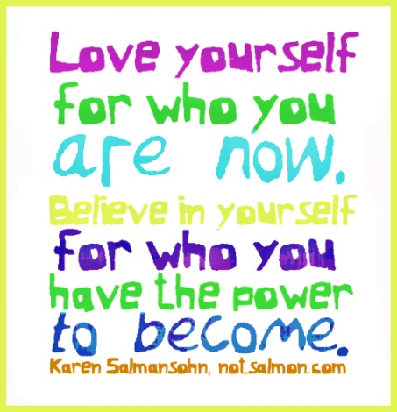

Inspirational Item
Each inspirational item is an abstract item with no ‘obvious’ link to the Bible or the Christian faith – this is where the challenge begins! We challenged students and teachers to find that link, to make sense of that item and see where it has meaning in our Christian lives.

Action/Response:
How might you respond?

