LEA Values; a framework for living

Values provide a framework for decision making. The Lutheran Education Australia framework, Lifelong qualities for learners “defines the ethos of Lutheran Schools: ‘As central to their mission and ministry, Lutheran schools seek to nurture individuals who are aware of their humanity, open to the influence of the holy spirit and growing in and living according to a cohesive worldview while living in community and reflecting the characteristics of God through core values, especially love, justice, compassion, forgiveness, service, humility, courage, hope, quality and appreciation” (LEA Statement of Values).

This resource provides thought starters, theological underpinnings and suggestions as to how this framework can be utilised in classroom devotions and college worship and staff bible studies.

A word of note: this resource has been compiled to run across campuses – so adaptation will need to be made to make it age appropriate. Use those resources that are helpful. If you find other resources, email them to me, so that they can be made available to others for future years.

Term 1 Week 3

LIFELONG QUALITIES FOR LEARNERS STATEMENT
Hope (expectation, trust in, faith in, anticipation, look forward to, expect, desire, aspire, optimism) …
Hope enables us to look forward with expectation and confidence, placing our trust and faith in God’s provision of the things we need to handle all kinds of situations and events that occur. Hope is openended, open to all possibilities and not limited by what we might wish for. Hope allows God to define our lives.
Psalm 31:14-15, John 6:20, Romans 8:38-39, Ephesians 3:11-12, Philippians 4:6-7 …

CODE OF ETHICS statement
Hope
We place our trust and faith in God’s provision of the things we need to handle all kinds of situations and events and look forward with trust and confidence
Therefore we:
+ appreciate that all interactions are opportunities for the Holy Spirit to work
+ actively seek to develop our personal resilience

Key Texts, Biblical Comment and Devotional Ideas:
Week 2
Philippians 4:6-7 “Don’t worry about anything; instead, pray about everything. Tell God what you need, and thank him for all he has done. Then you will experience God’s peace, which exceeds anything we can understand. His peace will guard your hearts and minds as you live in Christ Jesus.”

The context: Paul’s letter to the Philippians was primarily about encouraging this Christian community in times of adversity. Paul uses his own experiences to emphasis the resilience that followers of Christ can have in the midst of struggles, even death.

Teaching thought:
If one was to use modern media to interpret the central tenets of the Christian faith, one would come to the conclusion that Christianity is simply another ethical system to live by; one about which rules shaped action. However, to read through the gospels, one quickly discovers that that perspective could not be further from the truth. The Christian faith is all about freedom and life. By recognising who we are, we can springboard from that to live life in all its fullness. No longer does one need to hide behind external masks, because self-acceptance, or self-compassion (defined as people accepting themselves for who they are, warts and all) enables us to find our identity in Christ; thus we no longer need to worry about anything!

Discuss:
What is hope? Having come up with a definition last week, are there any changes you might like to make to that definition?
In what ways can having a confidence in God build an inner resilience to overcame all things?
Is hope essentially a religious idea? Why? Why not?
How does it look for a life to be hopeless? What does a hopeless world look like?
How could hope be shared to people who are seriously broken?

Additional Resources:
https://www.youtube.com/watch?v=2MKNsI5CWoU (Story about a family who end up doing something drastic to try and provide hope for their daughter – suitable for Senior Campus only)
How do you make sense of the drastic action that this child’s parents took? What does this suggest about the concept of hope?

Read the following article about self-compassion http://greatergood.berkeley.edu/article/item/try_selfcompassion
How can having confidence in God lead to a more self-compassionate self?

http://bible.org/article/hope and http://expreacherman.com/2006/11/20/what-is-hope/?
Two different biblical explorations of the meaning of hope

Symbols
What symbol best defines your understanding of hope?
What do the following symbols suggest about hope?
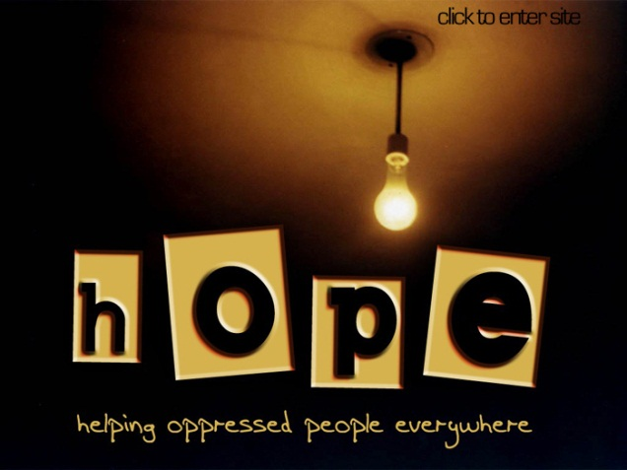


Inspirational Item
Each inspirational item is an abstract item with no ‘obvious’ link to the Bible or the Christian faith – this is where the challenge begins! We challenged students and teachers to find that link, to make sense of that item and see where it has meaning in our Christian lives.

Action/Response:
How might you respond to living with hope?

