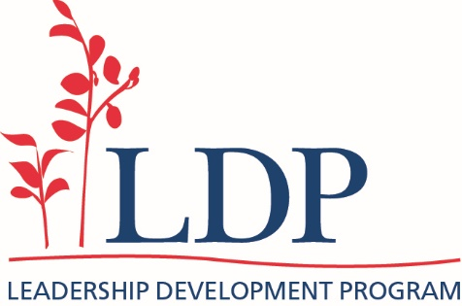

Principal reference: LDP selection - principal perspective

Principal to fill in this confidential form to provide details about the LDP applicant:

Principal feedback form

