Launch Activity “Who are we?”
(Who is God and how does He see us?)
Artefact | Explanation
Picture of baby’s hand | God knows us before we are born
Hand of God image - available Creative Commons
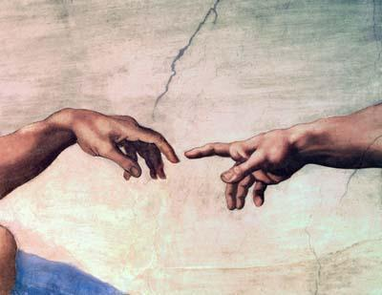

“Search Me O God” – Leigh Newton
Footprints poem
Prayer Book/ Used Bible
“You Say” Lauren Daigle 2017
https://www.youtube.com/watch?v=lKw6uqtGFfo Who you say I am
Decision making device | Free will/ does God make all of the decisions in our life?
Gardening artefacts/ plants | Co-carers of creation
gift | Individual gifts and talents
Scripture References | Psalm 139:13
Treasure/ treasure box
Literature | Wilfred Gordon McDonald Partridge  Treasure Box
Saint icon or image | We are seen as saints in God’s eyes
Black cloth/ judge’s gavel | Represents sin
Church image | Community, worship
Bowl and towel | Washing feet
Who am I in Christ? Poster

