Connect Session 3:
LESNW Option 1

Key understanding: Lutheran schools and early childhood services are communities that recognise that God has intentionally created each person and that each person is uniquely gifted to live in relationship with God and others.

Rationale:
Every Lutheran school and ECS is a community. As such all staff are part of a Lutheran learning community. The community can be anywhere on a range from fully flourishing to anguishing. The ideal would be that all communities are flourishing, i.e. that everyone in the community feels well, functions well and relates well with God and others.

This workshop will enable to participants to reflect upon the observable nature of their learning community. They will then be led to go below the surface to explore how an understanding of vocation and positive relationships contribute to a flourishing community.

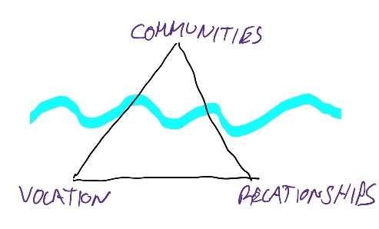

OUTLINE OF WORKSHOP:

What are the attributes of a flourishing community?
- Ask participants to write individual aspects of sticky notes.
- Participants sort and cluster
- Discuss

Which of these have I observed in my learning community?
- Participants journal their own personal responses.
- Discuss
Key understanding
- Introduce key understanding: Lutheran schools and early childhood services are communities that recognise that God has intentionally created each person and that each person is uniquely gifted to live in relationship with God and others.
- Observe any links to their own reflection about attributes of a flourishing community.
- Draw the above diagram and explain that:
  - Vocation helps us to understand the purpose in being created uniquely different (feel well, function well), which,
  - Helps us to be able to relate to God and others more positively (relate well), which,
  - Are significant ‘below the surface’ understandings of a flourishing community.

How am I unique and what is my unique contribution?
- Participants share an object, picture or symbol of something unique that they bring to their learning community.

Unpacking Vocation
- Watch : http://www.youtube.com/watch?v=ihnzFH2L818
- Discuss
- Read online resources about Vocation.
  - What did this make you think about?
  - What questions does this make you want to ask?
  - What is your understanding of vocation?
- Ask each group to share the item that created most discussion in their group.

Schools and ECS as a network of vocations
- Refer to Vocational Practices in Growing Deep
- Based on that, and your knowledge, list all the roles and vocations required in a typical Lutheran school. Identify the vocation, and how it contributes to the mission and ministry of the school.
- Participants identify a person from their learning community who contributes to building community which is not part of their job description.

My Vocation/s
- Map out the different roles/vocations you have. Identify what the role is, and what ‘service’ you provide in it.
- Reflect on:
  - What are some of the challenges you have faced in relation to fulfilling your different areas of responsibility?
  - What are some ways of ensuring that our areas of responsibility receive the time and attention they require?

Implications of an understanding of Vocation:
- Dot point the various aspects of Vocation (understanding)
- For each dot point, identify the implication for their practice and contribution to their learning community
- How does all of this contribute to a flourishing community?

Biblical reflection
- 1 Corinthians 12:12 - 13:7
- John 4:1-30
Journal
- Reflect on your day tomorrow. How can you take your understanding of vocation into tomorrow?

