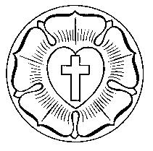
St John’s Lutheran School – Geelong

Christian Studies Planner
Unit Title / Topic  Relationships with God and other people |  |  |  | Band: A  Level: 2 |  |  |  | Date Term 3 2011.  Duration of Unit 10 Weeks
CB | CC | CL | CW | Teacher(s) Naomi Gibbons, Charlene Grieger & Melinda Troeth
Key Idea (s)  Key Idea 1  Christians believe that God creates people to live in relationship with him and with each other |  |  |  |  |  |  | Outcome (s)  CL 2.1 Students investigate and represent people’s relationships with God and with each other.
Unit Overview
CL 2.1 Christians believe God’s love and care of his created people stems from his desire to be in relationship with them. A relationship with God instructs and motivates people on how to live with one another. Relationships nurture people and enable them to develop their gifts and in turn nurture others.
Essential / Guiding Questions  What is a relationship?  Who do we form relationships with?  What does a positive relationship look like?  How does God have a relationship with people?  How can our communication with others form a relationship?  What does a healthy, loving relationship look/ sound/ feel like? |  |  |  |  |  |  | Resources  LIFE folder  CSCF Documents  A vision for learners and learning in Lutheran schools  The Bible  Children Story books
Links to Lifelong Qualities for Learners  - Self Directed, Insightful investigators  - Discerning, resourceful problem solvers & implementers  - Adapt, creative producers & contributors  - Open, responsive communicators & facilitators  - Principled, resilient leaders and collaborators  - Caring and steadfast supporters & advocates |  |  |  |  | Links to LIFE  - God creates human relationships  - God creates human beings |  |  |  | Links to other curriculum areas  - Integrated Studies  - Literacy  - ICT
Identify specific knowledge students need to achieve the outcome (students know...)  Human beings share a special relationship with God  God creates, knows and loves each person as a unique individual  God wants a special relationship with each person; love, trust, communication  Human relationships are part of Gods plan for people  God is shown to us through the ordinary lives of people  God wants people to love and respect one another  Jesus’ has demonstrated how Christians live in relationship with God and others  People need each other to meet their needs. |  |  |  |  |  | Identify what students will have the opportunity to demonstrate (students can...)  describe how God has created people with similarities and differences between individuals (eg, gender, ethnicity)  create a picture of how God sees uniqueness in his creation  discuss what being special means for them  investigate Bible stories of the friendship God initiates with people  investigate ways people express their relationship with God  retell stories of friendship that illustrate the biblical teaching on healthy relationships  describe the aspects of friendship that make them feel good about themselves  identify actions which demonstrate love and respect in personal relationships  explore pictures the Bible uses to help people relate to God  identify people who are important to them and record their understanding of the importance of other people in their lives  reflect on and demonstrate ways people show love and care for others  express God’s gift of people through the arts (eg, mural)  share stories that illustrate God’s love and reflect on ways people can show love to others
Sequence of learning opportunities:
Week 1: discuss what being special and unique means to the students.

Focus: Being special and Unique
Tuning In: (Read the background notes). Christians believe that we are special because God created us. Each one of us is different in our own special way, making us also very unique.
Read the book: ‘What I like about me!’
Discussion: What is special about you? What are you good at? What special qualities do you have? Be proud of yourself. Christians believe that God has special plans for each person. And that all people have great worth and value in God’s eyes.
Bible Reading: Get the students to open their Bibles and read together: Romans 12:6-8 (God has given different gifts) and 1Peter 4:9,10 (each of you has gifts). What are these Bible readings telling us?
Activity: Brainstorm different words which make us special and unique (kind, creative, caring, helpful, sporty, loving, happy, etc).
Each student is to then select the characteristics which represent them, and write them on the petals of the paper flower. Glue a photo of them in the centre.

Devotion: The meaning of unique: Give each child a small handful of play dough. Instruct them all to make the same object. Come together and discuss that even though they had to make the same thing, each were different, each were unique. Just like us. The children wrote all the things that were unique about themselves.
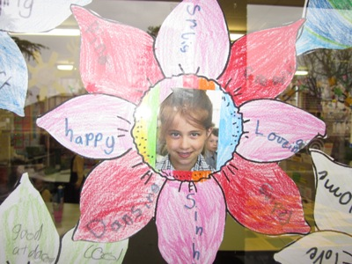
Week 2: create a picture of how God sees uniqueness in his creation. Book: Round fish Square bowl
Tuning In: Revisit how God created people as unique individuals. Each person is different in Gods eyes and each is special.
Read the book, ‘Round Fish Square Bowl’
Discuss how Gods creation is also unique. Help students appreciate the differences in people, animals and his creation. Go for a walk around the school paying attention to what we can see, smell and feel. Discuss how many different things the students can see and find that God has made. Gather a collection of different seeds, leaves, textures, sands and small items. How can people use these things? What special abilities has God given people to make something from his creation? (Trees, into paper. Flowers and plants into medicines etc) Together we collected these things from outside and created our creation table. The children took ownership of this and kept adding things to our creation table.
Activity: Create a touchy, feely mat of Gods unique creation. 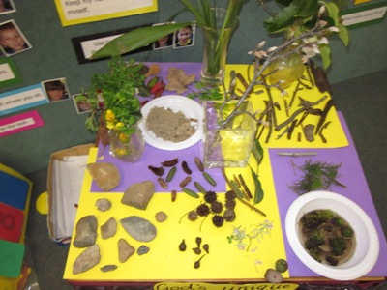

Week 3: describe how God has created people with similarities and differences between individuals (eg, gender, ethnicity)
Book: Quick as a Cricket, Christians believe that God creates people to live in relationship with him and each other.
Tuning in: Read the story “As Quick as a Cricket”
In the Bible there are stories of people that had special characteristics. Samson –known for his strength. David known for his talents as a musician and writer (Psalms) Dorcas- known for her care. Solomon-known for his wisdom. Zaccheus- known for his small stature. Each of these people were special and loved by God.
Place a mirror inside a shoe box. Get students to sit in a circle and look inside the box one at a time, without speaking.
Class Activity: Briefly-Write a class list that identifies the similarities and then differences between the children in the class.
Similarities: eg St.John’s., Play sport, wear the same uniform, do the same subject s. Level 2 students, play together
Differences:- Colour of hair, skin, eyes, ability to speak another language
Activity: Colour in the person to best represent yourself . Correct eye and hair colour, sport uniform or dance costume or special national dress. Label with your name.
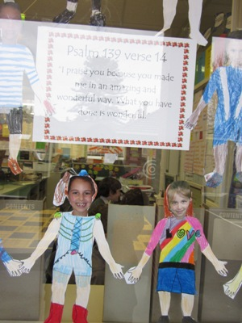
Week 4: investigate Bible stories of the friendship God initiates with people . retell stories of friendship that illustrate the biblical teaching on healthy relationships. Eg: David and Jonothan, Zacheuas, Mary/ Martha. Jesus and his disciples, Paul and Silus.
(See LIFE folder ‘God creates human relationships)
Tuning in: *Bible stories of friendship : Think about someone who is your friend, a really good friend. Think about how they treat you. What they say to you etc. What you say and do for them.
Now think of someone that you do not get along with as well as you do with your friend. How do they treat you? How do you treat them?
God created human beings to live in happy and harmonious relationships with each other- Genesis 2 : 18-25
Relationships protected: ( healthy)God expressed this through the 2nd of the 10 commandments. “ Love your neighbour as yourself” Matt 22.39
Broken relationships: Because we are human beings we are sinful and not capable of living perfectly. We have conflicts, fights and disharmony.
Restored relationships: Jesus came to restore broken relationships between human beings and God and to redeem ( bring us back to Him ) all human relationships. God calls people to recognise and repent ( say sorry) for their sins against other human beings. God offers forgiveness and people can have new life as his children and trust in Christ. He can help people in failed relationships. The restored relationship between people and God makes it possible to live in harmonious and loving relationship with other people.
Activity: Role play a situation where the relationship is broken through harsh words or anger.
Role play a situation where the relationship is restored through people saying “sorry” and offering to forgive one another.
List words that promote friendship. Kind, trust, thoughtful, compassion, empathy, share, friendly, smile, care, fun, listening, talking.
** make a friendship chain that has words on it that describe friendship.

Here is a record of the discussion that the children brainstormed. We referred to it in devotions especially when we were looking closely at our forgiveness value.

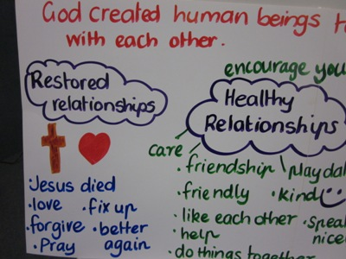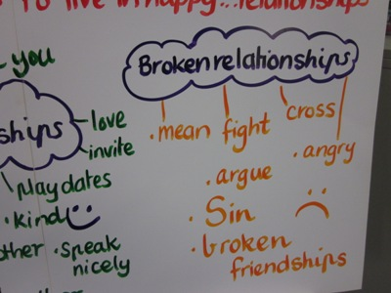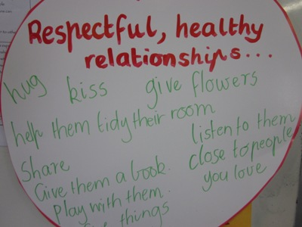
Week 5: investigate ways people express their relationship with God (See LIFE folder ‘God creates human relationships)
King David: Through Psalms. Paul: Evangelising to the Romans/ Greeks. Jesus: relationship with God through prayer, obedience, living a perfect life. Investigating ways people express their relationship with God.

Tuning in: Discuss how King David was a man of God. Even from his early life he devoted and depended solely on God. David had to learn very early on that his trust needed to be in Lord. From fighting Goliath, to finding refuge from his enemies that were trying to kill him, to becoming King of Israel and even in his years fighting as a warrior. David trusted God and had a personal relationship with Him. He loved God and frequently expressed his love, gratitude, concerns, anger and frustration to God through uses of poems and songs (Psalms) that are found in the Bible. Direct students to where Psalms is located in the Bible. Explain that David wrote most of the Psalms written there. They were written when he was a young man and throughout his life too. David was able to express to those around him and even to us thousands of years later his devotion to God.
How do people around you express their love and devotion to God? Discuss.
Read Bible passages from Psalms to share with the students (Psalm 139, 118:24,
Activity: Student completes a praise psalm that a Christian might offer to God. After reading many of the praises that David wrote in the Psalms the children completed a prayer of praise on the template provided. The used a word bank taken from some of David’s praises in the Bible and these helped the children write their own with a partner.
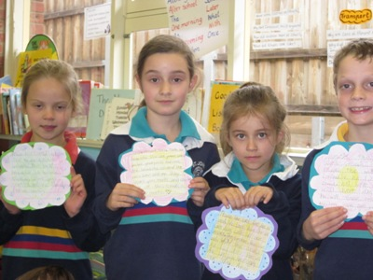
Week 6: share stories that illustrate God’s love and reflect on ways people can show love to others (LIFE: God creates human beings)
Eg: Stories, prodigals son
Read the story of the Prodigal Son (Luke Chapter 15:11-32)
Reflection: Who has the Prodigal Son hurt by his actions? How did the father show grace towards his son? How does your family show grace towards you?
Jesus used this beautiful parable to illustrate God’s desire to have everyone under the protection of His love. The younger son demanded his inheritance and traveled to a faraway land where he partied all his money away. When a famine came, he was forced to take the most humiliating job possible – feeding pigs. He was so hungry he was jealous of the food they ate. He finally came to his senses. He realized that his sins had cut him off from his Father and assumed he was no longer worthy to be called his son. He decided he would beg his Father to take him on as a servant.
Before he had even made it home, his Father saw him in the distance. He ran to his son and threw his arms around him. He put a ring on his finger, nice clothes on his back, restored him to a place of honor and then in case that did not make the point – he threw a party in his honor. God loves each person with an unconditional love the same way that the father in this story shows unconditional love to his returning son.

Have a student read from the Bible verse from Psalm 86:5. Discuss what it means to have God’s forgiveness and unconditional love such as the father’s in the parable.
Put together the memory verse from Psalm 86:5, “You, Lord, are forgiving and good, abounding in love to all who call to you”.

Activity: Students will create a heart shaped weaving activity.
Week 7: Identify actions which demonstrate love and respect in personal relationships identify actions which demonstrate love and respect in personal relationships.
Read the book: The big book of LOVE
Discuss with the students what is unique and special about their family.
- What do they do to show that they love you? How do you show that you love and respect them?
- What is so special about your Mum/Dad?
- What are you thankful for in your family?
- How can we show respect towards our family members?
Activity: Students can show their appreciation and love for their Mum and Dad by writing a thank you letter around the border of a butterflies wings. *
One each for Mum and Dad. Cut around the butterfly and snip the centre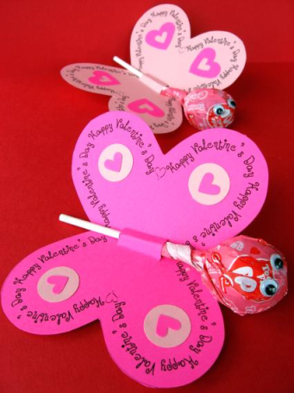 This is what the children made.
- Decorate with stickers, glitter
- Place the lolly pop in the centre fold.
- Students may also like to decorate the bookmark and give that as well.
Bible Verses:
- ‘To me you are very dear, and I love you.’ Isaiah 43:4
‘Children, obey your parents in all things. This pleases the Lord.’ Colossians 3:20

Week 8: describe the aspects of friendship that make them feel good about themselves
Tuning In: Describe the aspects of friendship that make them feel good about themselves.
God’s plan for people was to be together and to live in harmony with each other. He created Eve to be a friend and partner for Adam.
Ecclesiasters 4:9 Two people are better than one. They get more done by working together.
Stories of friendship:
Get the students to open their Bibles to 1 Samuel 18: 1-4 and discuss how David and Jonathan become friends.
- Discuss how friendships begin, what friends do together, ways friends help one another, and how we can stay loyal to each other.
- Complimenting each other, helping each other and being there for one another is often very important in building a strong relationship.
Activity: Compliment chart- In friendship groups of around 4-5 students, get them to record down what their friends say to them that makes them feel good about themselves.

Discussion: Share with the class different compliments we can give one another. Record them on large poster paper. When might we use these? How does it make you feel when someone compliments you?
- Encourage students to refer to this chart and aim for a classroom which is supportive of one another, encouraging and helpful.
- I like it when my friend says…
- My friends make me feel special when…
Book Work: You may like to then get the students to record in their books by finishing the sentences:
- I like it when my friend says…
- My friends make me feel special when…
- I like my friends because…
- Ask the children to draw something that shows friendship through acts of service.

Week 9: Identify people who are important to them and record their understanding of the importance of other people in their lives. Why does God want people to live in protected, healthy relationships? How can people do this? Write the children’s examples down as a record to keep.

Week 10: Concert ( revision ask the children what they have learnt this term. What is new to you? What will be helpful in your relationships? Also- complete the assessment sheet. See at end of Unit.

