Children were asked to write what they prayed about and if they wanted to they could write this down on the back of the survey sheet. (Also anonymous.)

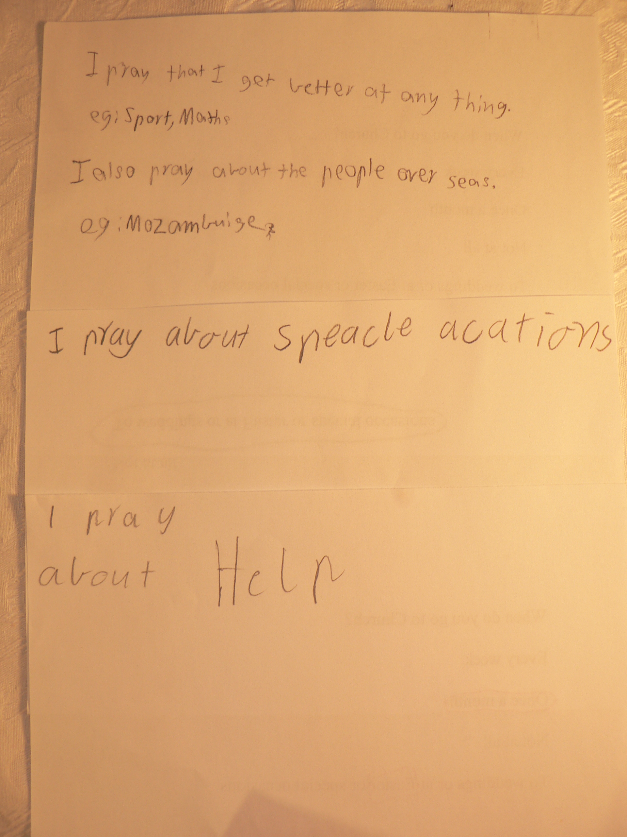
3SM statements
i pray about sick people and so that people will have a safe trip.
I pray that I will be able to go to church to learn more about God.
I pray about help.
I pray about people who are sick.
I pray about god the Holy Spirit, God the Father and God the Son and when someone is sick.
I pray that I get better at anything. Eg. Sports and maths.
I pray about people overseas eg. Mozambique.
I pray about special occasions.
I pray to have a good day.
I pray to keep my family safe.

Numerous children did not write anything or wrote that they did not pray.
Image – Three student’s statements.



