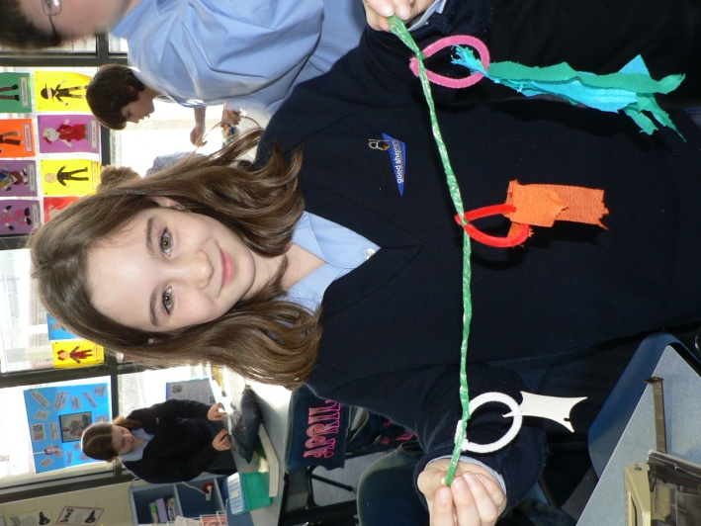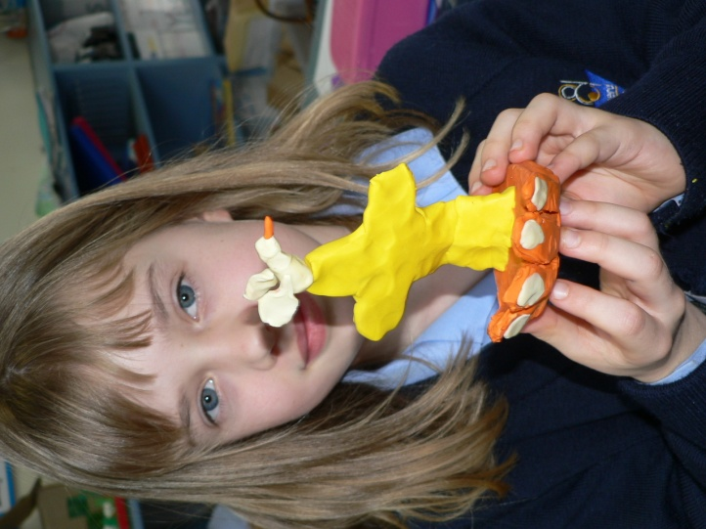
This student’s colours and materials represented Trinity.
This student used plasticine. She made the hand of God, the cross of Christ and the dove representing the Holy Spirit.
Appendix 5

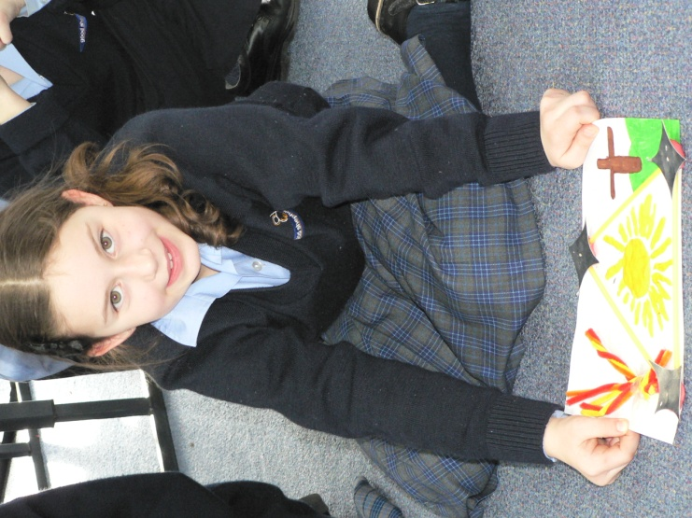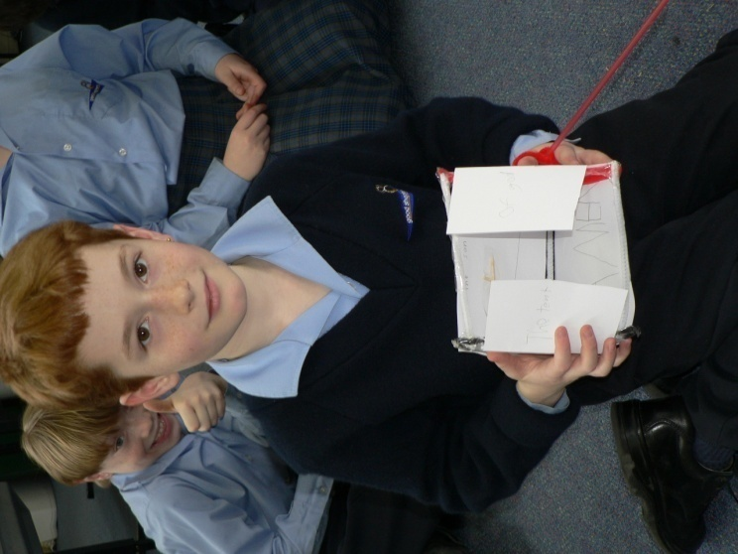
This student made a collage and designed a triangle to represent Trinity. She used images of fire for the Holy spirit, the bright sunshine in the centre as the Father and the image of the cross for Christ.
This student made a “Tent of God”. He began with a triangle but kept going into a triangular prism. One wall had God the Father written on it, the back wall had God the Son, the other side wall had the Holy Spirit. On the floor of the tent he had written “AMEN.”

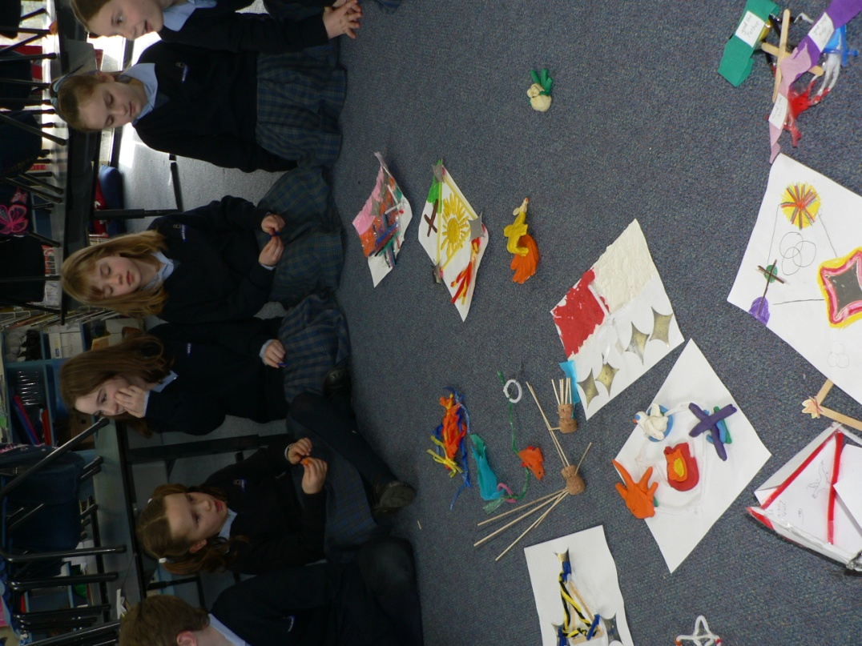
Appendix 5b

Children got to present and discuss their symbol. This showed a level of understanding that was recorded in the assessment folder.

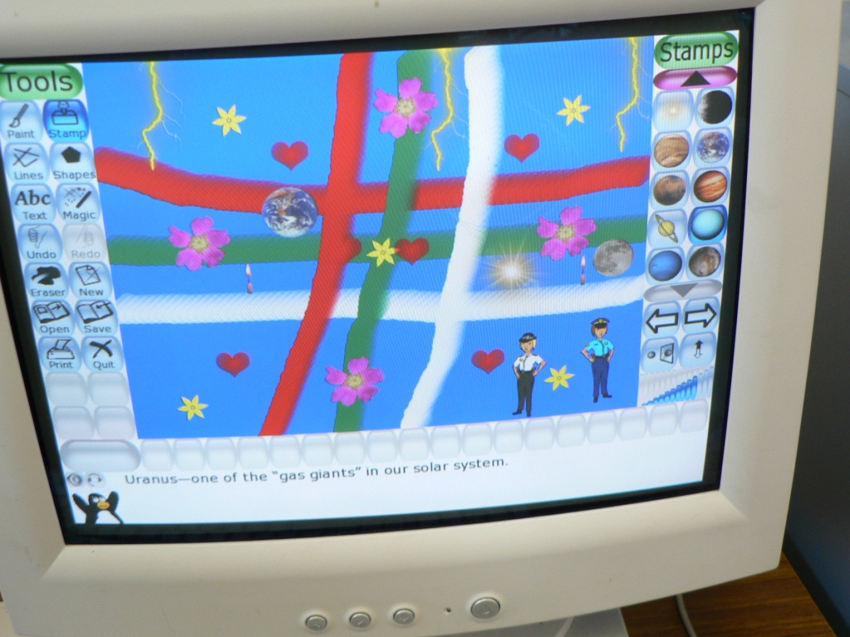
These are examples of student’s ‘TUX PAINT’ images of the Triune God. Children worked in pairs to do this.
Appendix 6

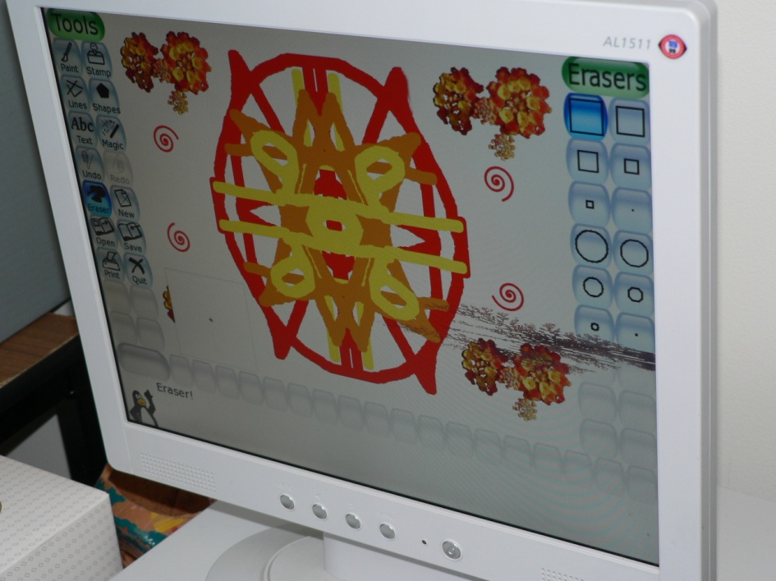

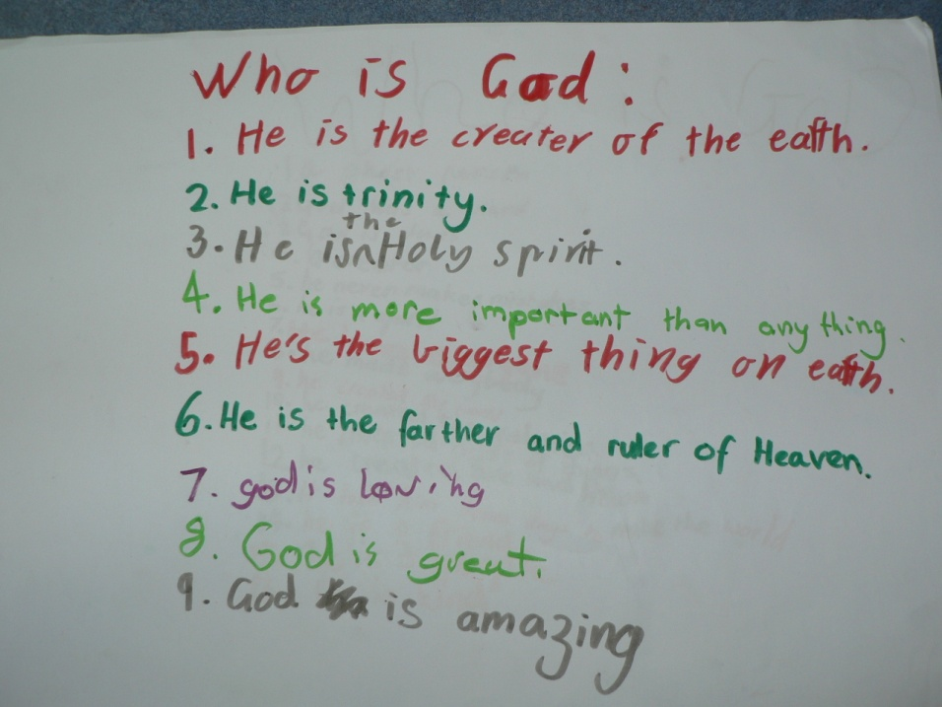
Tuning in – this is a brainstorming activity which was done with random groups of children.
This determined some of the overall prior knowledge of the class while also stimulating others who were struggling with contributing to the question.
Appendix 1
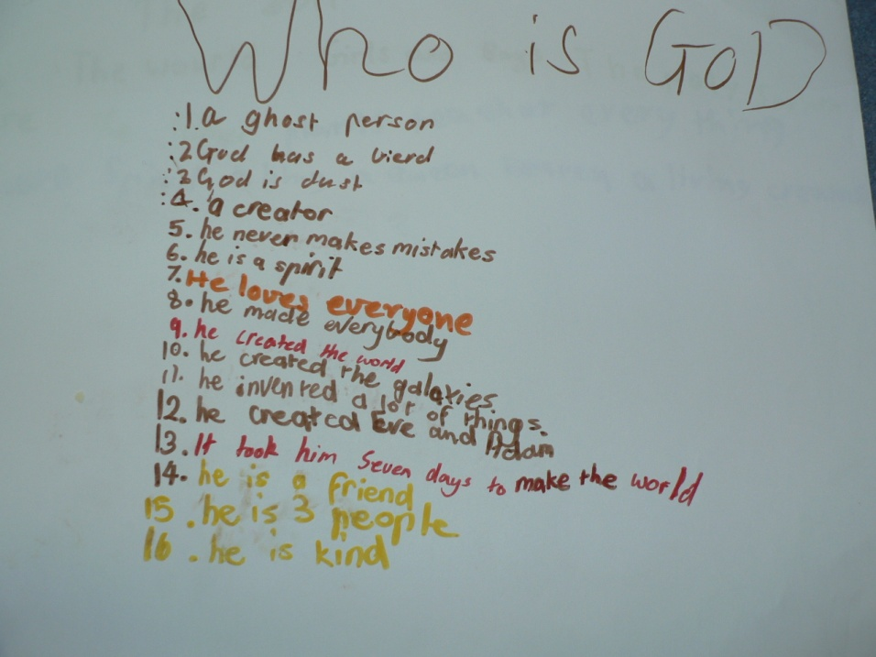
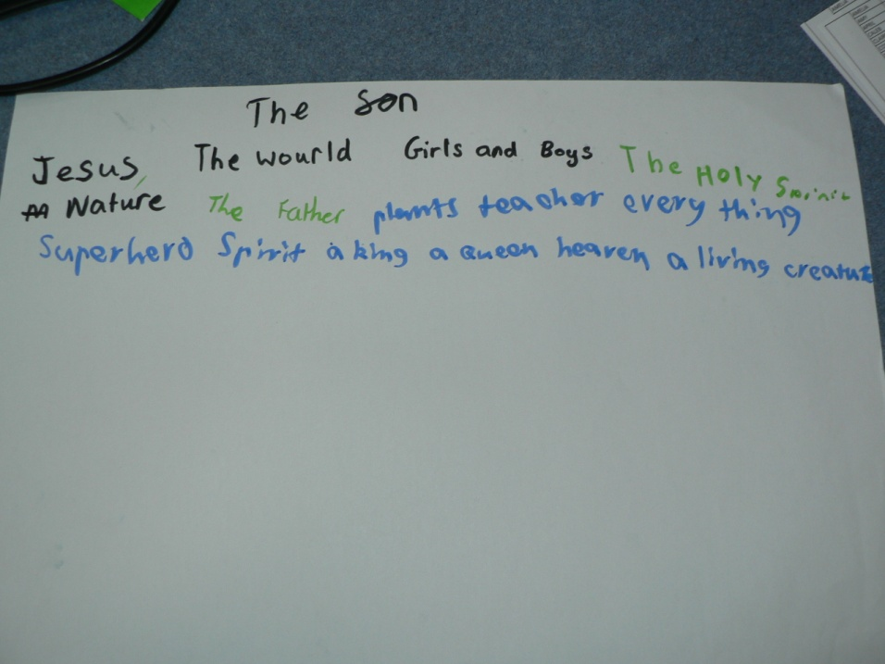

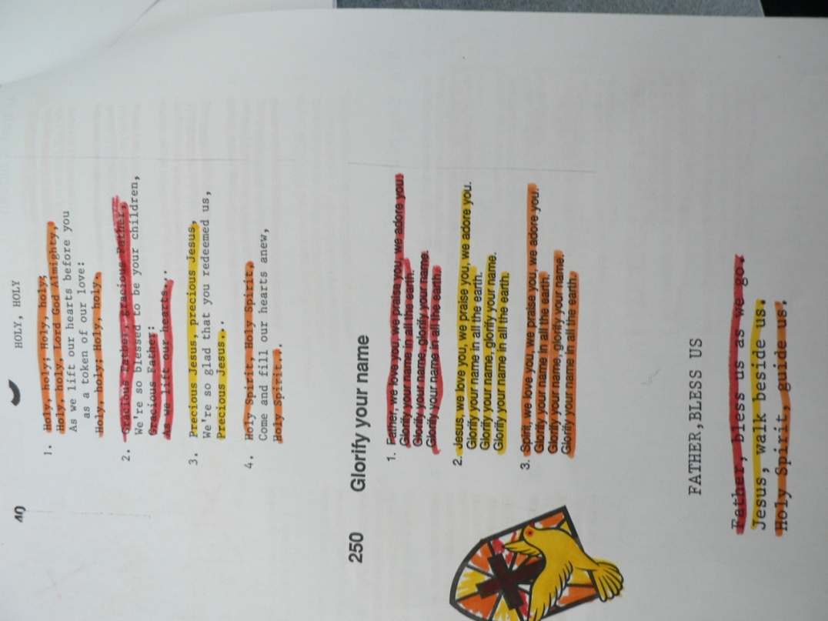
In pairs children would read familiar songs and reflect on parts that referred to the Father, the Son and the Holy Spirit.
Children highlighted these in different colours.
Appendix 4
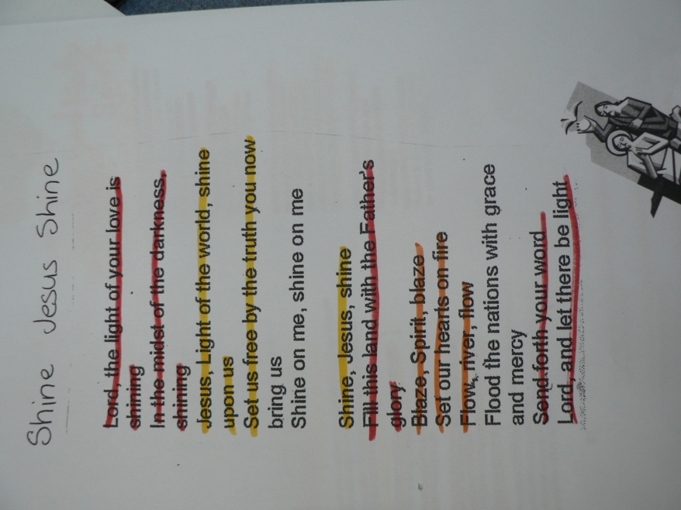

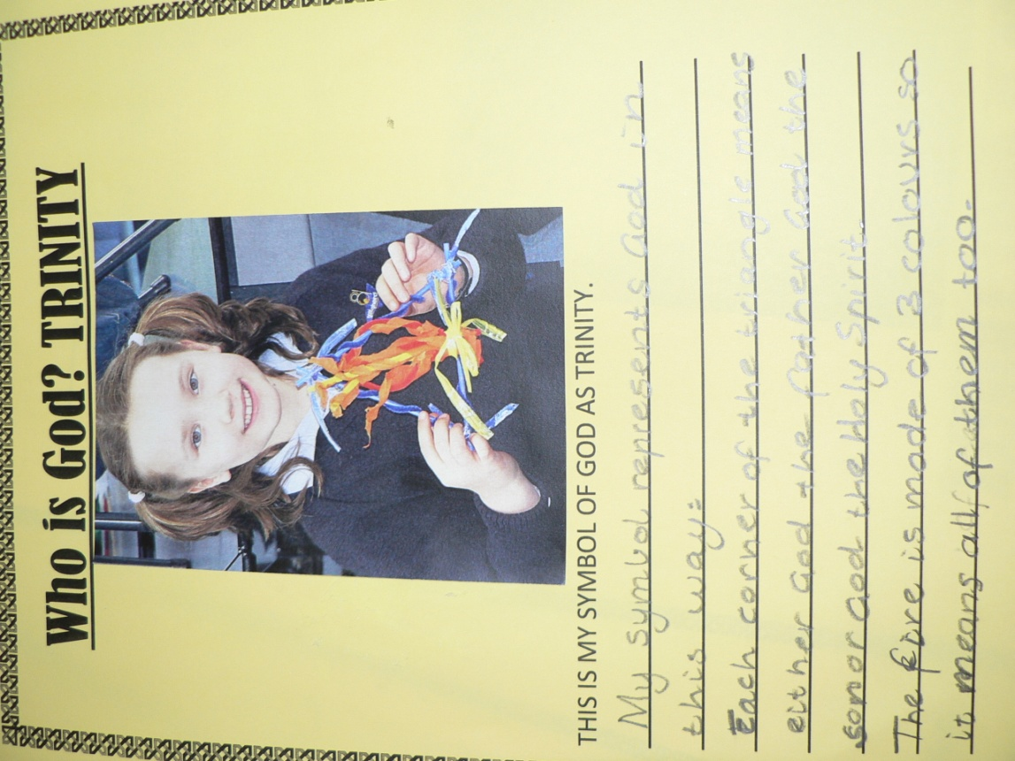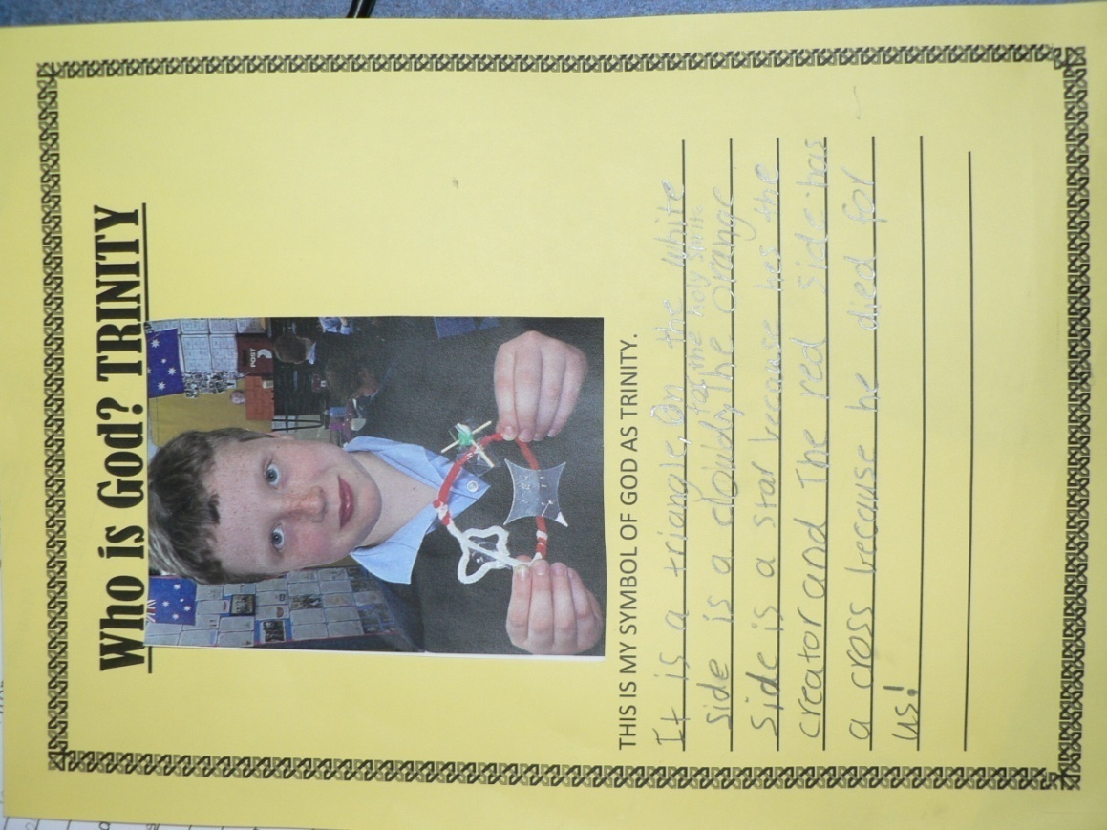
Children were really pleased with their symbols and so I decided to take individual photos of them with their symbol and they could record the description of it for their reporting journals.
Appendix 5a
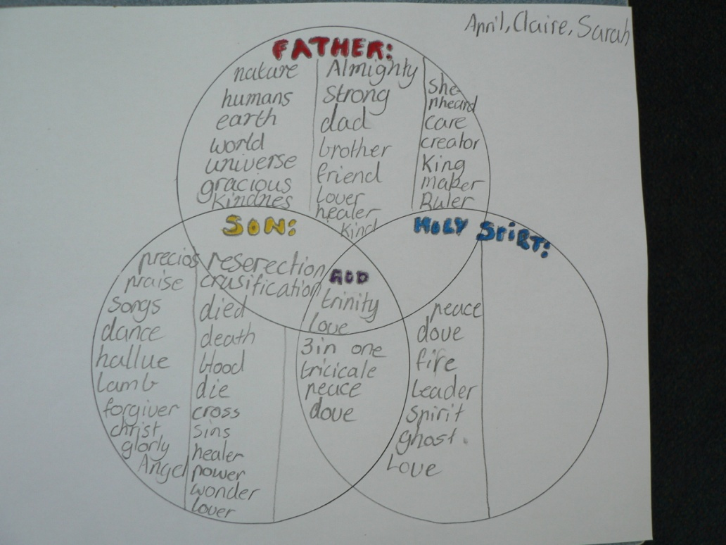
Appendix 7
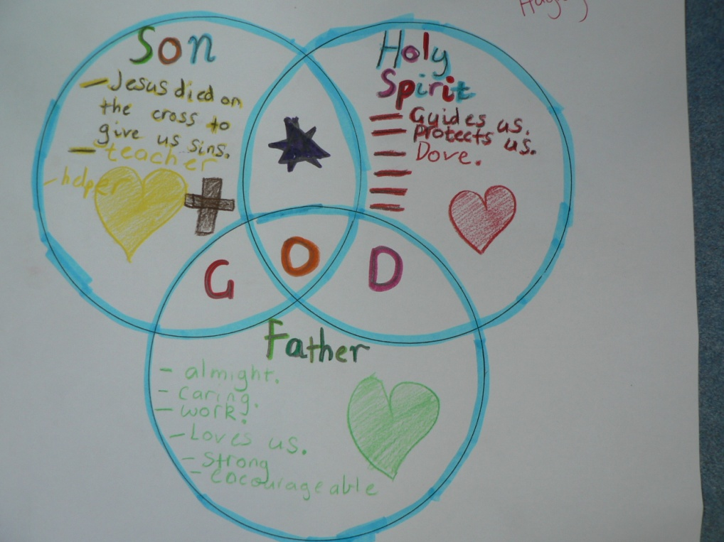
The Venn diagram was used as an evaluation tool. However listening to students as they completed this task gave me a greater understanding of how students were dealing with this concept. Some students felt more comfortable working together and I allowed this, though I observed everyone’s contributions.
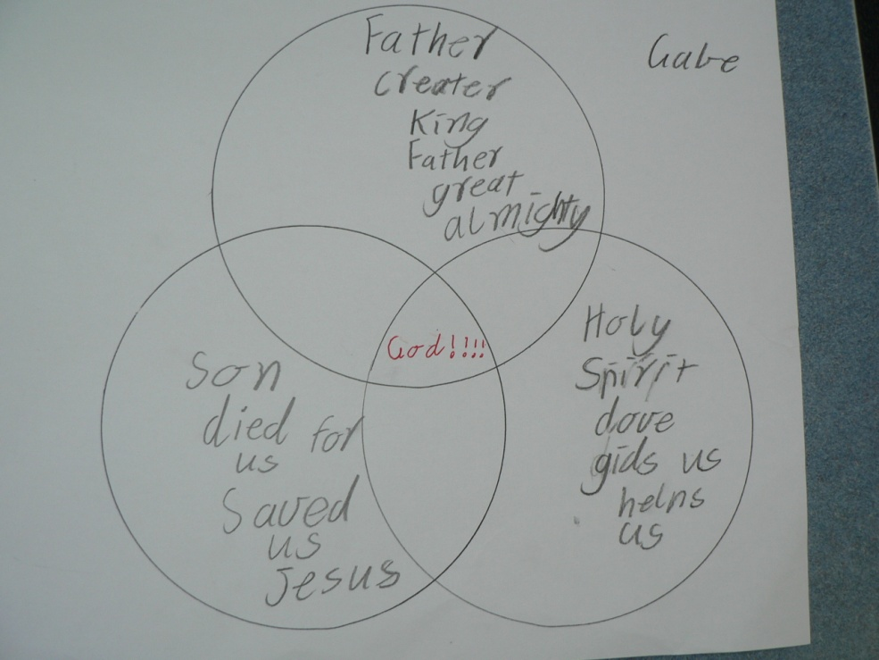
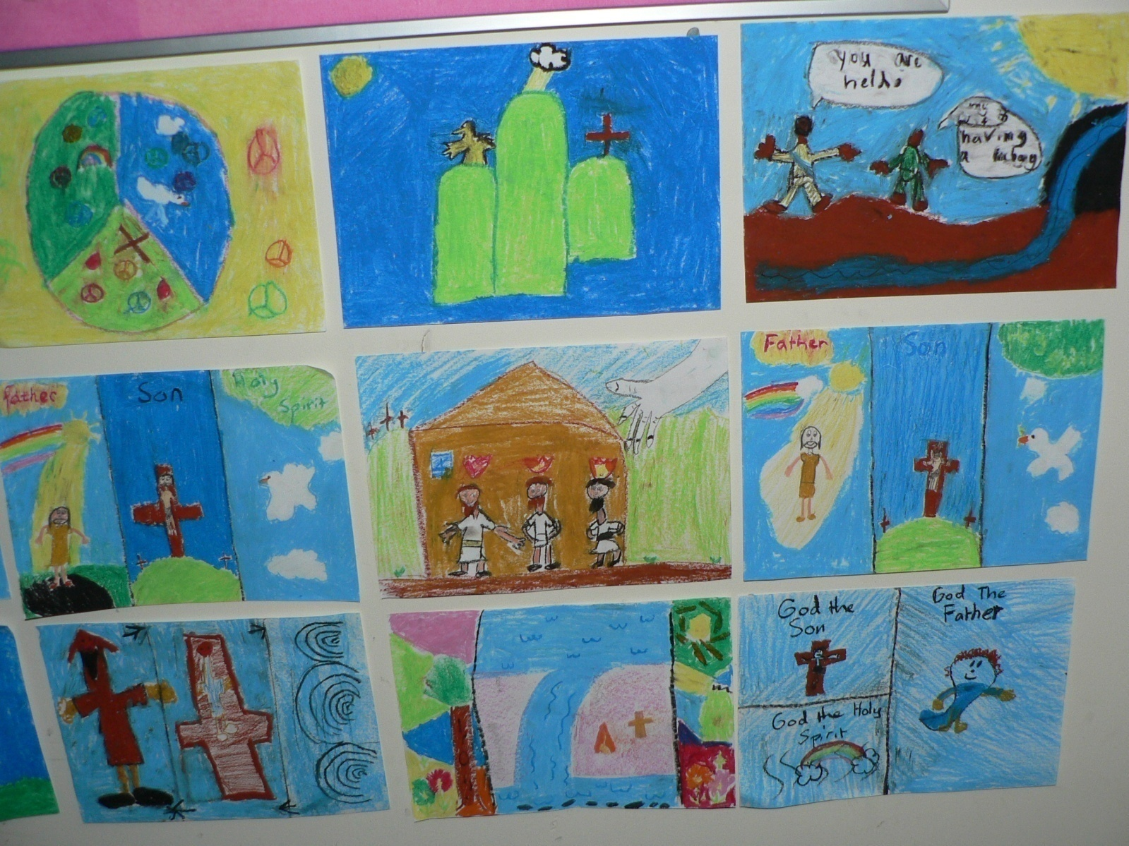
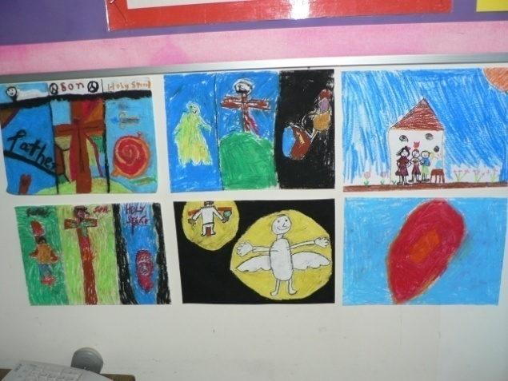
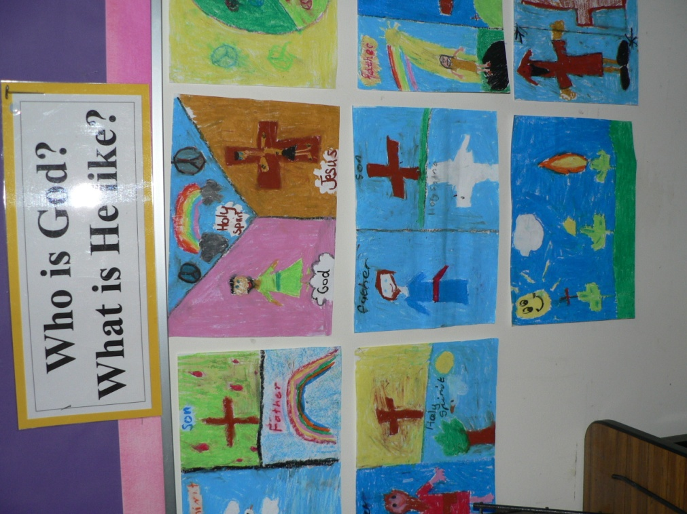
Images from children of God as Father, Son and Holy Spirit using oil pastels.
Do images show equal representation to the three parts of God?
Appendix 2

