UNIT FOCUS ON RESPONDING TO STUDENTS (CAPITALISING ON THE ‘UNEXPECTED’)
Excerpts from unit written by Trish Zirbel, Peace Lutheran Primary School, Gatton.

CB | CC | UNIT TITLE  The life of Jesus |  | BAND A  YEAR 2/3 |  | DURATION OF UNIT: 8 weeks
CL | CW |  |  |  |  | DURATION OF UNIT: 8 weeks
KEY IDEA(S)  KEY IDEA 2  The person and work of Jesus the Christ is central to Christianity. |  |  | OUTCOMES(S)  CB 2.2 Students gather and present information about the life and teachings of Jesus.
UNIT OVERVIEW  Students investigate, explore and discuss the identity, life and teaching of Jesus. The image of Jesus that students have developed through their experiences will be challenged as they explore his identity. The other focus of this unit is the ministry of Jesus with students exploring the message behind the miracles performed and parable stories told by Jesus.  This unit will build upon the knowledge students have of the life of Jesus and the stories he told. |  |  |  |  | CONTRIBUTION TO LQL
Peace is a ‘stage-based’ school, so students in this class are of mixed ability and are in Year 2 and 3. These students are typically 7-8 years old. Band A was chosen as most appropriate for the needs of these students.
This document tells the story of a unit which changed direction dramatically due to an activity that went exceptionally (and unexpectedly) well and sparked many ideas and questions that we as teachers decided were worth further investigation. We would never have planned to follow this path, but we are so glad that we did!
Initially we were going to begin by looking at the images of Jesus (see PowerPoint attachment), and then go on to focus on the actual teachings of Jesus. However, it was only when we showed the PowerPoint that we realised there were so many ideas to flesh out. We knew we could take the discussions that we had in the room that day further, so the unit became about both the identity and the teachings of Jesus.
STUDENTS/LEARNERS PROFILES  Because we had lots of new students with a very limited knowledge of who Jesus was, so we knew we needed to start the year with this unit to build their understanding.  Lots of children in the class can recall stories of Jesus and his teachings in simple ways, but we really wanted to challenge them to personalise that and get them to analyse their understandings – why do I think that? What does this mean for me?  The class consists of a number of students with reasonable background knowledge of Jesus and the Bible (from school/Sunday school)  There are a number of new students with very limited knowledge of Jesus and Christianity | ESSENTIAL/GUIDING QUESTION/STATEMENT  This is a simple question, yet it can be answered in so many ways. It is open-ended so that children with varying experiences, backgrounds and beliefs can engage and seek answers to this question. Some of our activities challenged children to look beyond simple and superficial answers and seek deeper understandings.  Who is Jesus?
RESOURCES TO SUPPORT UNIT  Images from web (on PowerPoint)  Crossroads Books 2&3 (produced by Catholic Education)  Children’s Bibles and bible story books  Video: Jesus (the life and ministry of Jesus)  We planned the unit with lots of activity sheets for the students to do, but found that we didn’t use them, because our discussions led us in a different direction – we decided to go where the students were leading us rather than having lots of sheets that the parents could see. | LINKS TO LIFE  LIFE  God Saves People Through Jesus (Band A) – model unit and menu  We looked at the LIFE folder when planning, which gave us ideas, guidance and discussion points, but we found that the unit ‘developed itself’, so we didn’t follow the model unit at all. This year we have become more ‘critical’ and discerning about what we take from the LIFE curriculum. We are asking ourselves if this activity or resource is serving our purposes of trying to investigate answers to our questions and engage students in thinking deeply.

Although we didn’t explicitly link this unit with English, we were doing a lot of critical viewing and analysing of images. This was done verbally. We also talked a lot about appreciating differences in opinion and perspectives.
This unit involved the students in lots of discussion, through which they frequently brought up and discussed questions about Jesus. Other students were then able to offer their answers to the questions.
STUDENT QUESTIONS | LINKS TO OTHER CURRICULUM AREAS  A ‘Personal World’ unit was being covered at the same time in integrated studies – the unit was ‘All about me’. The students were profiling themselves so we related that to the profiling of Jesus. | RESOURCES TO SUPPORT TEACHERS  LIFE curriculum  Theological notes  School Pastor – he planted the thought of challenging children
ASSESSMENT
This unit brought to our attention the importance of finding ways of recording evidence of student responses. We knew they were doing great stuff –but how do we show that to others? Where is our evidence? This is something we really need to concentrate on.
We still needed to get together to talk about the unit and to discuss how we could answer students’ questions.
Participation in discussion –this unit was heavily weighted towards observation of students’ discussion
Work samples – students wrote their own version of a parable of Jesus’ which went into their portfolio
There was a criteria sheet which goes in the portfolio which goes home

KNOWLEDGE STUDENTS NEED TO KNOW TO ACHIEVE THE OUTCOME (“students know…”)
We didn’t want to do a timeline of Jesus’ life, although we looked at a video of his life.

Our focus was on Jesus as an adult and how his life relates to our lives.
Jesus as human and Son of God
- Jesus’ birth, childhood
- Jesus’ adult life
- Jesus’ death, burial and resurrection
- Jesus at God’s right hand

Jesus’ ministry
- Jesus’ teaching about love, forgiveness
- Jesus’ teaching about the way to live
- Jesus interacted with all kinds of people
- Jesus helped and healed people

We initially began the unit looking at images of Jesus from the internet. I looked at the images and thought my students were not old enough to appreciate and critically look at the images. I was worried about the students’ reactions and also I felt that maybe it wasn’t ‘right’ to share images of Jesus that were unconventional – I was a bit fearful about it all! My teaching partners (and the pastor) convinced me that it would be fine, and that what we wanted was to really find out what students’ image of Jesus was and to question that. We didn’t want our students to accept ideas unquestioningly but to really think and to understand that they could make Jesus personal to them – we wanted them to talk about this in relation to their lives.

The activities shared here focus on the early part of the unit where we explored the identity of Jesus – there were other parts of the unit where students studied the parables and miracles of Jesus and the message of these.
LINKS  TO LQL | LEARNING OPPORTUNITIES | OPPORTUNITIES STUDENTS HAVE TO DEMONSTRATE (“students can…”) | DIFFERENTIATION
 | Images of Jesus – Children view a slideshow of various images (on PowerPoint) and discuss different representations and how they fit into pre-conceived images. The children will then be given the opportunity to demonstrate their preferred image of Jesus  Concept map – of children’s knowledge of Jesus – who he was and what he did  Video – this video shows a more ‘conventional’ portrayal of Jesus’ life.  Pastor – the students had a number of questions from the unit, so he came in to answer tricky questions and also to talk about what Jesus most likely looked like  What do you see through Jesus? Students get a photocopy of the final image (blanked out inside Jesus’ body) – they illustrate what they see through Jesus | Describe Jesus’ personality  - explore and present findings of the way artists, songwriters, films and books portray Jesus  - describe the people that Jesus met and how he showed love for them  - identify stories of forgiveness in the Bible and tell of times when they have felt or acted the same way (eg, Joseph, the forgiving father)  - discuss the message of some of the parables Jesus told  - construct scenarios which explore what Jesus might do in selected situations | The nature of these tasks was fairly open, so all students were able to respond. Really it was the teachers’ expectations that changed from student to student.  The last image on the slide show certainly had a big impact on the students and generated a lot of discussion, so we decided to use that image at the end of the unit for children to show what Jesus means to them, posing the question ‘What do you see through Jesus?’

Work Sample – What do you think Jesus is like?
This activity was done after we looked at the PowerPoint images of Jesus. I simply asked the students to draw a picture showing how they saw Jesus. This was after we had had a lot of discussion about how different people (including the artists who created the images we had seen) saw Jesus in different ways.
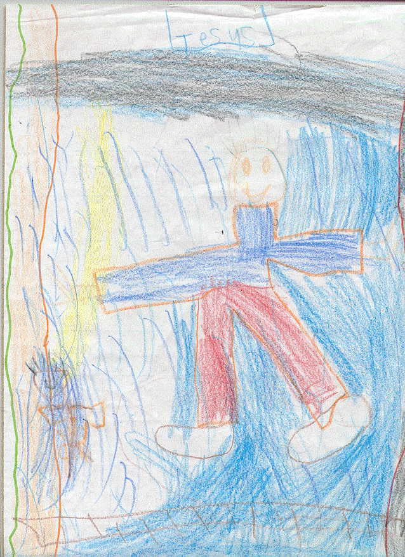
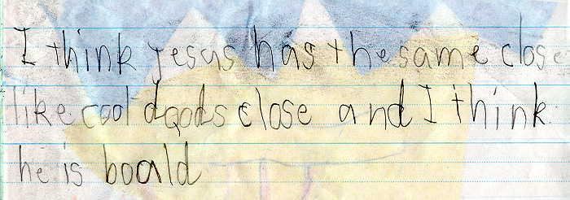

Work samples – What do you see through Jesus?
After I saw how the students responded to this image in the PowerPoint, I copied the image and ‘blanked out’ the inside of Jesus’ body. At the end of the unit, students were given this sheet and after discussing how Christians see Jesus having personal meaning to them, students were asked to draw something inside Jesus’ outline to show what they see through Jesus.
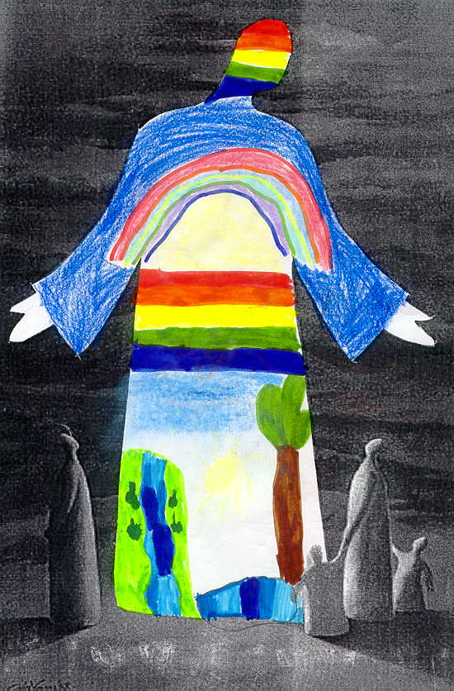


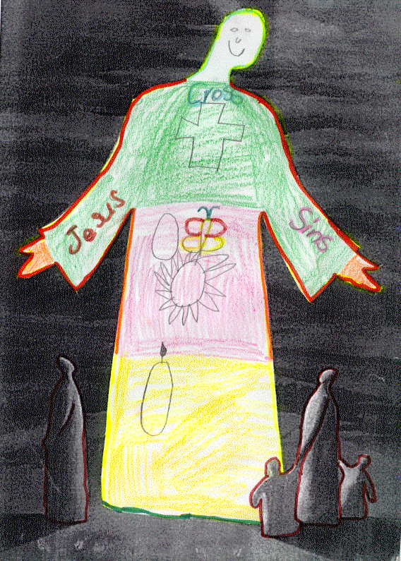
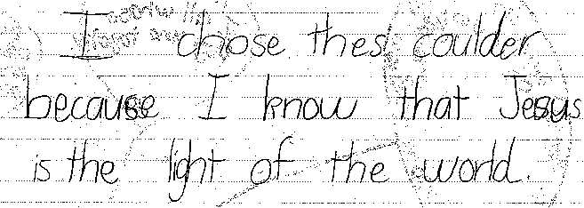

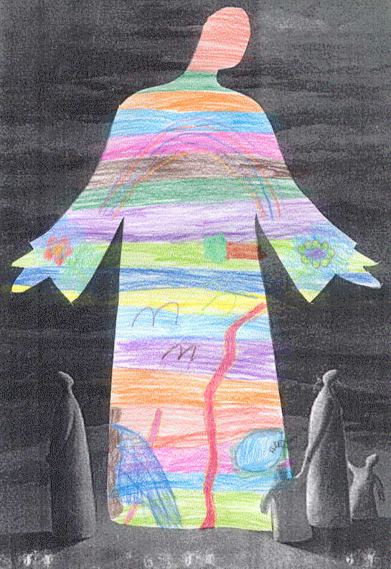
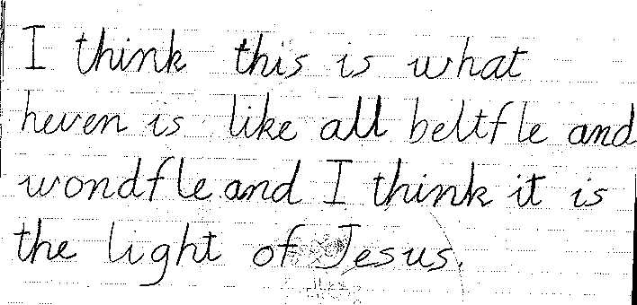

Work sample: concept map
This sample came from another part of this unit, where students had been investigating the ministry of Jesus, and the messages he gave to people. Students had reflected on the idea that loving God and others was the central message of Jesus about how he wanted them to live their lives. This is one student’s concept map of how he could show that love in various contexts.

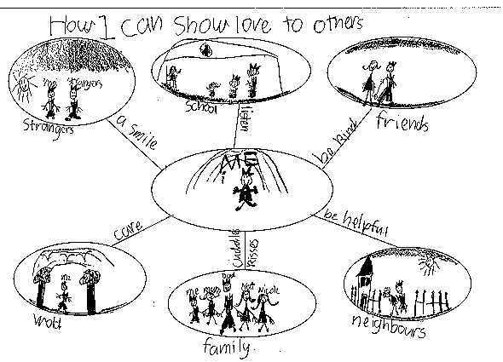

Work sample: Construction of own parable focusing on a teaching of Jesus’
This sample also comes from another part of the unit not focussed on in this document. We had read a range of parables Jesus had told and discussed the meaning of these. We were able to identify as a class the main themes of these parables. Students then needed to work in small groups to write a parable of their own, developing a message which was similar to the messages of one of Jesus’ parables.


